ECUMENICAL SERVICE FOR PEACE
(SEP)

ANNUAL NARRATIVE REPORT FOR 2018

B. P. 122 14 Yaoundé—Cameroun
Tél. : (237) 2 22 31 20 05/22 31 20 06
Fax (237) 222 31 22 55
E-mail : servicehumanus@yahoo.com
Web site : www.servicehumanus.org

TABLE OF CONTENT
- GENERAL INTRODUCTION
- REPORTS
- WORDS FROM THE CHAIRMAN OF THE BOARD OF DIRECTORS AND THE DIRECTOR
- MISSION STATEMENT
- COMPTE RENDU DE LA FORMATION SUR LE RENFORCEMENT DES CAPACITES EN GESTION DES PROJETS
- CAPACITY BUILDING
- Taking down notes / prise de notes
- Reports and documentation for office use and website
- Pictures taking for website and for documents archives
- L’ATELIER DE FORMATION SUR LES TECHNIQUES D’ANIMATION
- L’ATELIER DE FORMATION SUR DES LOGICIELS EXEL ET POWERPOINT
- RAPPORT DE L’ATELIER DE FORMATION SUR LA CONCEPTION ET LA MISE EN ŒUVRE D’UNE ACTIVITE DE CAPITALISATION
- RAPPORT DE L’ATELIER POUR JEUNES DEVELOPPEMENT ET PRATIQUE DE LA CITOYENNE ACTIVE
- RAPPORT DE L’ATELIER POUR JEUNES DEVELOPPEMENT ET PRATIQUE DE LA CITOYENNE ACTIVE

- CONCLUSION

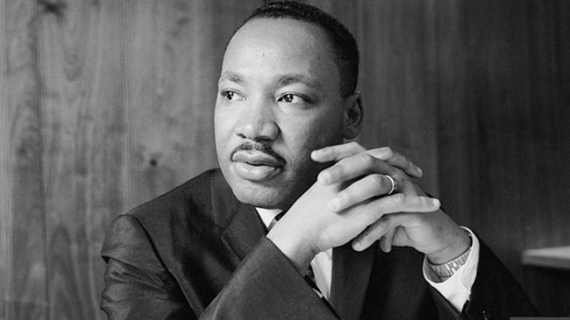

« Non-violence means avoiding not only the external physical violence but also internal violence of the spirit. You only refuse to shoot a man but you refuse to hate him. «

MARTIN LUTHER KING, JUNIOR
CIVIL RIGHT LEADER

MISSION STATEMENT
Founded in 1995, the Ecumencial Service for Peace (SeP) is a Christian, ecumencial and interreligious organisation whose mission is to contribute to a non-violent social transformation. Founded on Christian bases, it aims at setting up a society of participation based on justice, peace and reconciliation.

OUR MISSION
To contribute to non-violent social tranformation drawing on Christian values to create a society of participation based on justice, peace and reconciliation
OUR STRATEGY
- Organise training sessions that apply to Non-violence and non-violent conflict resolution, civic right and non-violent social transformation, socio-political leadership
- Organizes related events through the medium of conferences, colloquium, exhibitions and seminars
- Create campaigns to advocate both independently or jointly in accordance with pressing social issus
- Produces, publishes and circulates posters, information sheets, articles, videos and books
- Offer mediation and conciliation services for non-violent conflict resolution
- Provides humanitarian volunteers when needed for social and humanitarian action
OUR OBJECTIVES
- To spread the philosophy and techniques of non-violence and non-violent conflict resolution
- To seek and study obstacles to just peace and its alternatives through mediation and the quest for reconciliation
- To stimulate and support non-violent social action
- To promote and support the fight against misery and poverty
- To encourage training in civic, social and humanitarian action

MESSAGE FROM THE CHAIRMAN
OF THE BOARD OF DIRECTORS
On behalf of the Ecumencial Service for Peace (SeP) staff and Board of Directors, it is my pleasure to you the Annual Report of SeP, which demonstrates our achievement in 2018.
The year witnessed positive operational developments. The recruitment of a new Director have assured our ability to help continue with the work for peace. We look forward in framing our strategic plan of intervention and execute it through partnership and networking.
Our mission is to continue to move forward. This report tells you about some of the accomplishments of this year. May I also take this opportunity to wish everyone a peaceful and rewarding year 2019. May the good Lord renew the energies, devotion and inspiration of all workers of SeP.
Rev. Prof. Anyambod Emmanuel Anya
Chairman of the Board of Directors

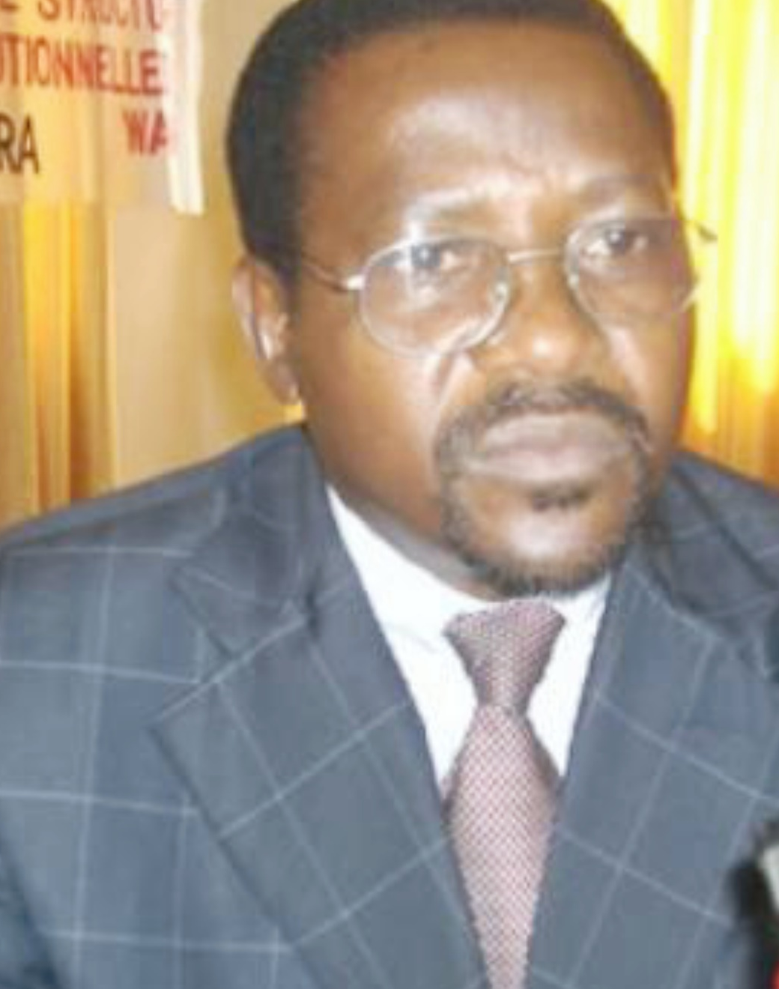
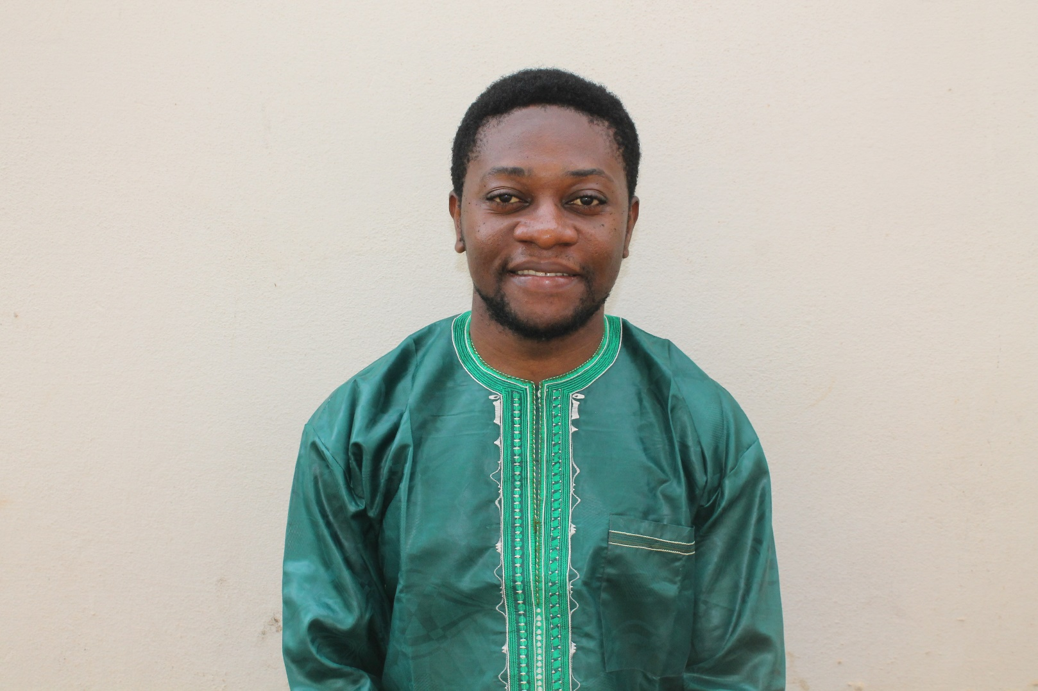

MESSAGE FROM THE DIRECTOR
We all have a duty to make change happen or to be part of the change process. The Ecumencial Service for Peace (SeP) role has centered on contributing for a positive change of the Cameroonian society.
We have contributed to generate evidence to sensitize the public in accordance with pressing social issus. At the same time and in collaboration with a partner organization, a capacity-building program was implemented in view of having a competent staff to respond to the organization’s objectives.
This report shares the work of the Ecumencial Service for Peace for the year 2018. Special thanks to the president to give a technical support for the capacity-building program.
Finally, we say thank you to SeP Board of Directors, members, staff and interns. We are together and hope to contribute to rely on your support in the coming year.
Fomekung Solomon Hope
Director

GENERAL INTRODUCTION
The year 2018 was a smooth year at the Ecumenical Service for Peace. Some activities scheduled, presented and validated by the board of directors were implemented. The organisation participated actively in network activities. The Norbert Kenne Memorial Peace House continued to provide services to clients.
However, the year also came up with its difficulties. Some projects written and presented to funders were not funded. In addition, some activities scheduled in the 2018 work plan were not executed due to insufficient funds. All these elements made 2018 made 2018 a busy and a challenging year.
- NGO Activities

  - Summary of the 2018 work plan

The implementation of this work plan derived from one general objective and four specific objectives, each of them having axis of intervention with identified activities to reach out the said objectives. The objectives were
General objective:
- Revamp SeP into a vibrant and responsive organisation
Specific objectives:
- Ameliorate SeP funding capacities
- Increase SeP visibility as an NGO
- Improve on the skills and productivity of SeP’s workers
- Increase the organisation of workshop, conferences
Each specific objective had an intervention strategy (Axis of intervention) with identified activities as presented on the table below:

NGO activities focus around the key axis of the organization spelt out in its 2018 work plan.

Nº | Activity | Expected result | Indicator | Source of verification | Person in charge
1.1 | Identification of the number of parish churches of the Eglise Evangelique du Cameroon (E.E.C) and the Presbyterian Church of Cameroon (P.C.C) in Yaoundé | The various churches are identified by SeP | Number of churches identified | Document presenting the mapping of churches | -Director  -Volunteer
1.2 | Transmission of letters to the head of each parish for rendez vous solicitation | Appointments are obtained in the various parishes | Number of letters transmitted | Minutes of meetings | -Director  -Volunteer
1.3 | Meeting with the heads of each parish to advertise SeP’s services | SeP services advertised | Number of pastors met | -Minutes of the meetings  -Articles on website | -Director  -Volunteer
2.1 | Building of a new website for the organisation | SeP’s website revamped | Number of visitors of the website | Website link | -Director  Webmaster
2.2 | Production of a terms of reference document on SeP’s new communication strategy | Terms of reference document elaborated | Number of terms of reference document | SeP’s archives | -Director  -Intern
2.3 | listing of current and past institutional and financial partners of SeP | List of partners elaborated | Document presenting the list of partner | SeP’s archives | -Director
2.4 | Inform institutional and financial partners about SeP actions and new initiatives | Financial partners informed about SeP’s new initiatives | Number of financial partners informed | -Mail  -Letters | -Director
2.5 | Update attractive visuals reflecting SeP's vision | SeP’s visuals updated | Number of visuals updated | -Leaflet | -Director
2.6 | Portrait valorisation of the history of SeP (pictures of former directors) | Portraits available at SeP | Number of portraits hanged | SeP’s offices | -Director
2.7 | Representing the organisation in network meetings | SeP’s visibility increased | Number of meetings attended | Pictures  Activity reports | Director
3.1 | Training in project conception and elaboration | Knowledge and skills acquired in project conception and elaboration | Attendance list of the training  -Pictures | Report of the training  -website | -Director
3.2 | Training in writing reports, articles and taking of pictures for activities | Knowledge and skills acquired | Attendance list of the training  -Pictures | Report of the training  -website | -Director
3.3 | Training in the use of excel and PowerPoint | Knowledge and skills acquired | Attendance list of the training  -Pictures | Report of the training  -website | -Director
3.4 | Training in the monitoring and evaluation of projects | Knowledge and skills acquired | Attendance list of the training  -Pictures | Report of the training  -website | -Director
3.5 | Training in workshops and seminar animation technique | Knowledge and skills acquired | Attendance list of the training  -Pictures | Report of the training  -website | -Director
3.6 | Training in capitalisation of activities | Knowledge and skills acquired | Attendance list of the training  -Pictures | Report of the training  -website | -Director
4.1 | Organization of a conference on extractive industries | Participants sensitized the topics related to extractive industries | Attendance list  Pictures of the event | Report of the conference  -website | -Director
4.2 | Opening of a multimedia documentation center on peace, non-violence and human rights (library) | Documentation center opened to the public | Number of visitors at the center  Number of books available | SeP’s library  -website article | -Director
4.3 | Working visit in the headquarters of the two churches (E.EC and P.C.C) | Working visit done and SeP’s new director and perspective presented to church heads | Mission order of the activity  Pictures of meetings | Report of the activity  -website | -Director
4.4 | Workshop on the sharing of SeP’s vision | Knowledge acquired on SeP’s vision by SeP members | Attendance list of the workshop  Pictures | Report of the activity  -website | -Director
4.5 | Capacity building workshop of board members on mediation | Knowledge acquired on mediation | Attendance list of the workshop  -Pictures | Report of the activity  -website | -Director

CAPACITY BUILDING TRAINING SESSIONS

4. DES L’ATELIER DE FORMATION SUR DES LOGICIELS EXEL ET POWERPOINT

- L’ATELIER DE FORMATION SUR LES TECHNIQUES D’ANIMATION

- Workshop report on the capacity building
of SeP and DMJ members on the development of reports, writing articles for the internet, reporting and taking pictures for the website.

- COMPTE RENDU DE LA FORMATION SUR LE RENFORCEMENT DES CAPACITES EN GESTION DES PROJETS
DES

COMPTE RENDU DE LA FORMATION SUR LE RENFORCEMENT DES CAPACITES EN GESTION DES PROJETS
FORMATION ASSUREEE PAR LA DYNAMIQUE MONDIALE DES JEUNES (DMJ) SUR LE THEME : FORMATION PRATIQUE /APPLIQUEE SUR LA GESTION D’UN CYCLE DE PROJET
Le vendredi 16 Février 2018, s’est tenue au sein du Norbert Kenne Memorial Peace House une formation appliquée sur la gestion d’un cycle de projet, organisée par la Dynamique mondiale des jeunes. Celle-ci s’inscrivait dans la logique du SeP de vouloir renforcer les capacités des membres de son équipe.

Déroulement de l’atelier
La formation a commencé à 9h par une prière dite par Donald Tchekankou, suivie de l’allocution du directeur de la DMJ qui a invité les différents participants à se présenter. Pour cet exercice, chacun s’est attribué un adjectif formé avec la première lettre de son prénom. Par ailleurs, les participants ont formulé leurs attentes et craintes, puis le directeur de la DMJ a déroulé les objectifs de la formation.

Résultats attendus :
Les résultats escomptés de l’atelier de formation étaient les suivants :
- -Décrire et analyser un contexte problématique à l’aide des outils de gestion du cycle de projet
- -Identifier différentes stratégies opérationnelles en fonction des opportunités et des risques liés au contexte
- -Planifier une intervention en utilisant l’approche du cadre logique
- -Evaluer les ressources nécessaires selon les objectifs du projet

Objectifs spécifiques
Elle visait par ailleurs à :
- -Renforcer les compétences d’analyse et de synthèse des participants pour une bonne compréhension des problématiques liées à un contexte déterminé ;
- -Doter les participants d’une connaissance pratique des différentes composantes d’un projet et leur apporter les compétences fondamentales pour qu’ils puissent jouer un rôle actif dans la conception de projet, l’écriture de proposition et la budgétisation.

Objectif global
La formation avait pour visée de soutenir le personnel du SeP dans le processus de conception de projet de l’écriture de propositions de qualité.

Module 1
La séance a effectivement débuté par un premier module basé sur l’analyse du contexte et l’identification des problèmes. Dispensé par Arnauld, un membre de la DMJ, ce dernier a s’est servi de la technique de l’arbre à problèmes pour expliquer le processus de détermination du problème central dans un projet et partant, de l’intitulé du projet. En substance, l’on commence d’abord par examiner les conséquences qui sont les effets manifestes visiblement perceptibles pour trouver le problème sous-jacent qui en est la cause. Le questionnement de ce problème permettra par la suite de trouver les origines, mieux, les racines du mal. Ceci n’est donc qu’une suite de pourquoi dans un sens « up-down ». Tel est le cheminement de l’explication de l’arbre à problèmes. Par la suite, le directeur de la DMJ a suscité un brainstorming sur la définition du terme projet. Ainsi, l’on a pu retenir que le projet est un ensemble d’activités mises sur pied pour quitter d’une situation indésirable (que nous voyons) à une situation indésirable (que nous souhaitons). Après la partie théorique, l’on est passé à l’exercice pratique d’application en se servant de l’idée de projet sur la formation des jeunes aux techniques de résolution non violente des conflits. Durant cet exercice, les formateurs ont formulé quelques conseils, notamment :
- -Le manque n’est pas un problème, c’est qui entraîne le manque qui l’est ;
- -Ce n’est pas l’intensité de la situation qui fait le problème, tout est question de cohérence ;
- -Ne rien rejeter du brainstorming : un problème peut être une cause ou une conséquence dans un autre sens…
Par ailleurs, en ce qui concerne la rédaction du contexte et de la justification du projet, le directeur de la DMJ a affirmé qu’il importait de dire ce que l’on entend faire (situation désirable) après la description de la situation (manifestations et problème).

Module 3
Le troisième module était centré sur la planification des interventions et consistait à la construction des objectifs, résultats et indicateurs. Entre autres, l’on a retenu que le résultat doit être tourné vers un changement. Autrement dit, il répond à la question de savoir : « quel est l’acquis que j’ai après avoir implémenté mes activités ? » Par ailleurs, il existe 2 types d’indicateurs à savoir, l’indicateur quantitatif et l’indicateur qualitatif. Cette présentation a été suivie d’un exercice pratique proposé par son auteur.

Module 2
Le second module portait sur l’identification des stratégies opérationnelles pour répondre au problème. Présentée par le Secrétaire Executif de la DMJ, ce dernier a mentionné que la stratégie est définie ou éclairée à partir des causes principales. Elle renvoie par ailleurs à la méthodologie (comment ?) et aux activités (plans et programmes d’activités). Suite à cela, les participants ont été soumis à un petit exercice pratique qui consistait à dérouler les activités à intégrer dans la stratégie de formation découlant de l’idée de projet étudiée.
Le directeur a ensuite donné quelques exemples d’outils d’analyse, à l’instar du SWOT (Strength/Weaknesses/opportunities/Time) ou FFOM (Forces/Faiblesses/Opportunités/Menaces).

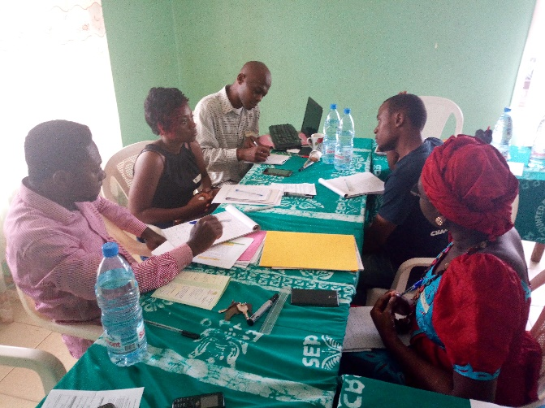
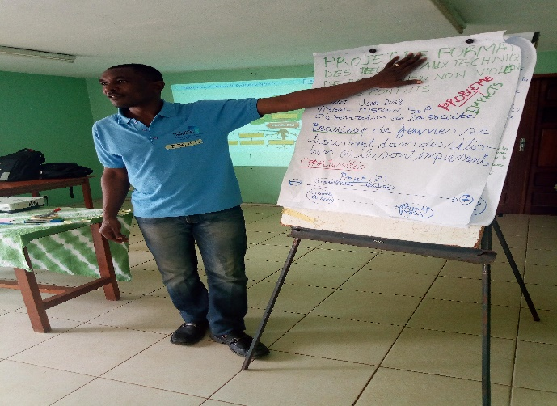

Conclusion
La formation pratique sur la gestion d’un cycle de projet était un événement très enrichissant en termes de capacitation des membres du Think Tank du SeP. Toutefois, quelques uns ont prétendu être restés sur le faim, sollicitant de ce fait d’autres séances d’approfondissement.

Evaluation
L’atelier a pris fin par l’évaluation de la formation par les participants, suite à laquelle le directeur du SeP a formulé un discours suivi de celui de la DMJ. Une prière de clôture dite par ce dernier a clôturé la séance à 17h 30 précises.

Module 4
Le quatrième et dernier module, présenté par la directeur de la DMJ portait sur la planification détaillée et l’analyse des ressources. A cet effet, il a suscité un brainstorming des membres du SeP sur les différentes activités réalisables dans le cadre du projet en conception. Par la suite, il a abordé la notion de ressource en faisant noter qu’elle se définissait en fonction de sa rareté, ou était caractérisée par sa limitation. Les différents types de ressources énumérées étaient : les ressources humaines, matérielles, financières, informationnelles, et temporelles. Après cet exposé, l’on a procédé à un exercice pratique portant sur l’élaboration détaillée des activités et des ressources nécessaires pour les réaliser ; et la définition des montants détaillé et global y relatifs. A la fin, le directeur a relevé la nécessité de rechercher les actions les plus pertinentes pour une meilleure réalisation de l’activité ; autrement dit, il faut se référer au résultat.

Workshop report on the capacity building
of SeP and DMJ members on the development of reports, writing articles for the internet, reporting and taking pictures for the website.

INTRODUCTION.

Capacity building (or capacity development) is the process by which individuals and organizations obtain, improve, and retain the skills, knowledge, and resources needed to do their jobs competently or to a greater capacity (larger scale, larger audience, larger impact, etc). in this light, following SeP trimestrial program to reinforce the capacity of its volunteers to make effective their services, the Director promised to organise a capacity building program which took place on the month of April at the Ecumenical Service for Peace premises. This training program were jointly organised by SeP and DMJ. Two sister NGOs in Cameroon who fight to ameliorate youth conditions in Cameroon through youth empowerment and peaceful means.

II - Executive Summary.

Following the organisations ambitions to better train its volunteering staff, to render its services more professional and methodological, the Director of SeP in partnership with DMJ organised a capacity training program on “Reports writing, article writing for internet and Picture taking for website.” The participants were all SeP volunteering staff and other from DMJ. Given that SeP has a new Director with a youth team that accompanies him to carry out his day to day duties.

III - Objectives: there are both General and Specific objectives.

General objectives: To reinforce the capacities of SeP volunteering staff on reports writing, Article writing and Report Writing for SeP. Specific objectives:

- improve upon the capacities of SeP volunteering staff.

    - Train the youth staff on how to take down notes for reports

    - Train the volunteers to know how to take quick notes while considering the most essential points
    - Train them how to take different kind of expressive pictures.

IV - Methodology.

Two methods were adopted in the training program which are the practical and the theoretical method. In this light all facilitators made use of documentation to present their exposes. They also made use of practical work to make the training more lifely and participatory. In this, from the unset, from what was prepared by the facilitator, he gave the opportunity to every participant to read at least a paragraph to avoid the session from being boring or sleeper. The facilitator made use of effective facts finding that was documented and that could be found and compared with other exposes proving the veracity of the training program content.

V - Expected results
This part concerns the long and short term results while including the expectations and fears of all the participants.

VI - Expectation from participants.

Exit from this training with the techniques of writing reports and articles. Learn how to Shoot for SeP website, learn how to shoot and write articles properly, learn to write professional activity reports, master the different types of writing reports or articles.

Fears of the Participants.

The time is insufficient, that we will lose out of time scheduled for the program, that the time imparted to run for the progress of the formation is small.

1.1- Some basic principles to be considered in taking notes.

Note taking is an important part and it has its materials like its block notes, pen and some. Generalelements. When you want to take notes, you should have your bloc note in which you do all what you deem important while including all the necessary details like event, activity, time and when work is done, you can confirm it’s done and effective. The way you write depends on the time and type of information you want because at some points some neglected information’s may turn out capital in a particular activity.

In organising the elements in taking notes you shouldorganise and present well your rough paper work in such a way that some other person can easily read them out. You should avoid interrupting the interviewee to write what he is saying and should not over focus on writing only but you look the interviewee from time to time. At times it’s important to record with your phone that will permit you latter to re-write them dawn thereby making a good report.

Module 1
- Taking down notes / prise de notes
1.4 - Types of Reports.

There exist three types of reports basically, which are; annual, semestrial and final reports.

Presentation of a report of a given activity.

Headline page: tittle of the project, activity tittle, and date if possible time.

Introduction: brief recall of the different parts of the program from the context to the results.

Activity presentation: organise them by articulation with titles, giving a feedback of what was done and what methodology was used. Verify that was is written is based on the verifiable date from the activity and if there were group works you can give the results that were out listed.

Analysis of the activity: Registered results that were successful, difficulties encountered during the training session or meeting.

Suggestions and questions: Here you can bring in new contributions and maybe a new methodology that can be used.

1.2 - The notionof reports: typology, formats, steps and writings.

The difference between a reports the other forms of writing, follows a chronological order meanwhile the others do not follow the chronological order. Moreover the report is very detailed meanwhile the other will not take all is to considerations but only the essential points that will be made useful later on.

1.3 - How to proceed in writing a report.

Here it means to write dawn everything that has been said during the session. It is a document that analysis a situation corresponding to a given situation so as to compare it to the objectives fixed at the beginning. And it permits the later to know if we have attain the objectives or not at the end.

- Cover page.
Tittle, number of the project, date, period and page number of the project. The more the size of the period the denser the activity to be carried out. The number of the project depends on the number given you by the financial donor but internally the organisation may just write a general report including all ongoing projects.
- Executive summary
Of the given and ongoing project.
- Report of the activity
Organise them by the results, objectives, and you have to recall all what was prepaered as general and specific objectives. You must make an analysis of the results that will permit you understand whenever you are progressing or regressing with the activity. The list of the facts to be presented must not contain all the details but the most essential points.

- Analysis of the project program
This permits you to know which the weak are and strong points, opportunities and threats to the project activity. What are the principal issues to be done in the period that follows?

- Cover page:
project title, project number, period of the report and date. Here we are recalling the important points that were t be achieved in the trimestral plan.
- Executive summary:
brief recalling of the important points during the time, period the meeting or session was held.
- Report of the activity:
organised by results, give a feedback of the progression of the project activities. Verify that what is written down is done on verifiable facts coming from the monitoring and evaluation plan.
- Analysing the program
Registered results, we also have to see in what you have done what succeeded and what did not succeed and if it did not work you should spell out what were the causes of this failures and what can be done in order to avoid this same failures in future.
- Perspectives
(plan pour la périodedes prochains rapports). With all what has happened you should do a projection for what will follow for the next session so as to permit everyone to be able to know and understand what has been planned for the next semester.

- TRIMESTRIAL REORTS

- ANNUAL REPORT
This principles are; the article must be captivating, when the text is too long, very small writing it becomes difficult to read. Moreover the article must not have grammatical faults. The text should not be too long propositional to the size of the laptop.

- CONTENT OF AN ARTICLE
An article is different from a report given that you appreciate it from a specific angle. Because you only use a particular aspect to elucidate on when writing an article. It’s important to always begin with the facts, it answers to “who, what, why, how and what.”The information’s that are most important comes at the beginning of the text. Conclusions are very necessary but mustn’t be obligatory, the text should not be found in several bech end sites. The title of the article must be attractive to the reader.

- STYLE
Long phrases must be avoided, stylish writings must be avoided, and the sentences must be simple and expressed in short, aligned and be uniformed.
The presentation must attract the lecturer because, he is the consumer and he is the one helping to understand that the product is good and thereby permits to understand the strength and weaknesses of the work done by the owner of the website.
You should make short tittles and short sub tittles and make sure, the numbering should be done in a hierarchical order.

- STRETURE F AN ARTICLE
Generally, when you are writing an article for the internet, you should use times new roman, inter-alignment 1.5, centralised, font type 12.

- PICTURES.
The pictures must be of good quality, must not be flew and it should be very expressive. Pictures participate at the level of the presentation and should be used proportionally to the size of the page, pictures must expressive.

- TITTLES.
There exist two types of articles; Explicative and Allusive. Explicative article summarises the article meanwhile the Allusive article makes a closer connection between the article and its content.

- ARTICLE FOR THE INTERNET

It must have the following characteristics.
Net, expressive, fact finding (renseignant), beautiful, the facts, the development and angle of interception. At the end of this module, we took a brake to take a family picture which was carried out at the premises of SeP. After this session was the group work of two members each per group, in which we were out to point out the following
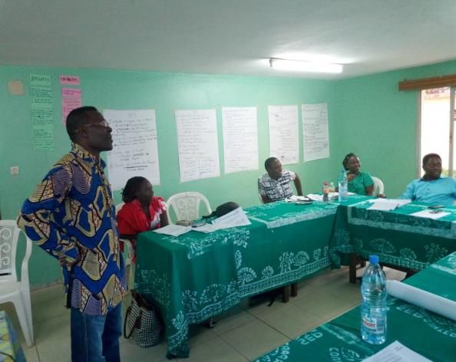
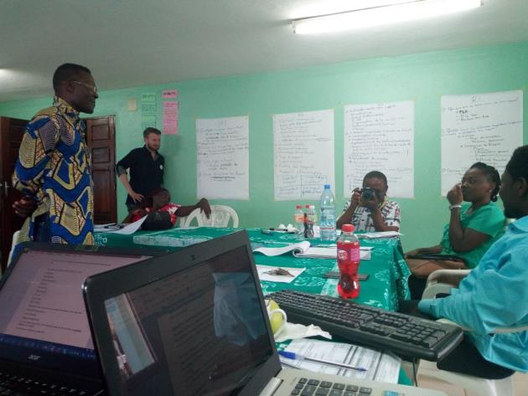
Answers
- Dates, results, suggestions and propositions, analysis, pictures
- Name and title of the person writing; usages of several types of numbering
- An activity report
- A chronological report
Questions

1. The elements that are missing,

2.The elements that are irrelevant?

3. What type of report it is?

4. What is the form of this report?

- CHARACTERISTICS OF A GOOD IMAGE

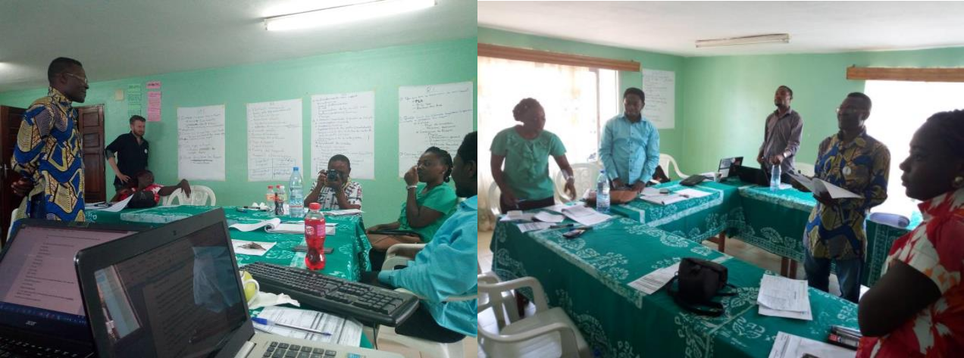
- what is the general objective of my report?
Report is equal to transformation an information on an even that has happened already.
- to whom is the report destined?
- It refers to a target population and it should be a well-known public? Does this public likes reading?
- Can they retain long text?
- Do they need much comments?
- What is really relevant for the target group?
- I know what I want, I know my public and I know on what to insist upon”

- what should I put into my report?
A report documents facts and therefore I put only what is pertinent. You should use a simple language, short description, and uses descriptive pictures, make suggestions on how to ameliorate a given situation.

Module 2
REPORTS AND DOCUMENTATION
FOR OFFICE USE AND WEBSITE
- REPORTS AND DOCUMENTATION OF FACTS

I classify them in a chronological order I collect data and present them in the right order. By alphabetical order, by chronological order, by order of importance, by numerical order and by alpha-numerical order.

I choose the type of classification in every part of my reporting relation to the type of informationto be reported and finally to the person to who it’s destined.

- How to present a report
- some principlesin presenting a report
Organise the content following a coherence, make much illustration with pictures, graphics, and drawings. Make simple short pictures and illustrative. Make short descriptions of the events. Do not make careless affirmations put prove it betteroff analyse them.At the end of this session, we undertook a lunch break of 45minutes composed of (cakes, fruits juice, tea, coffee, apple fruits and industrial drinks.)

Answer 1
Direct Destination were:Director of SeP, the administrative council of SeP, and the financial funders.
Indirect destinations: Civil Society Organisations (CSO), elections Cameroon (ELECAM), the public, researchers, political parties and the media.

Answer 2:
Who is destined to? Whatis the objective of this report? What are the results of the training program? What are the propositions brought in?

Answer 3.
- -Cover page (tittle of the project, intitule and date.)
- -introduction (rappel, parties principale and TDR)
- -déroulement de l’activiste (articulation, méthodologie, données et résultats.)
- -analyse (réussitesenregistré et difficultés,)
- -suggestions et perspectives.

QUESTIONS
1. To whom is the project destined

2. What are the elements of the report?

3. What are the steps or parts of a report?

In this work three groups were formed to answer to all three questions. Answers to these questions were;

After the midday break we undertook into a group work of two persons per group out of three groups in total. The groups worked on the theme:

Report presentation and highlight the main objectives. To write a report a report on the training program of senatorial elections observation organised by the Ecumenical service for peace (SeP).

In this light three questions were outlined to answer

- CLASSIFICATION OF DATA IN THE REPORT

- GROUP PRACTICAL EXERCISE

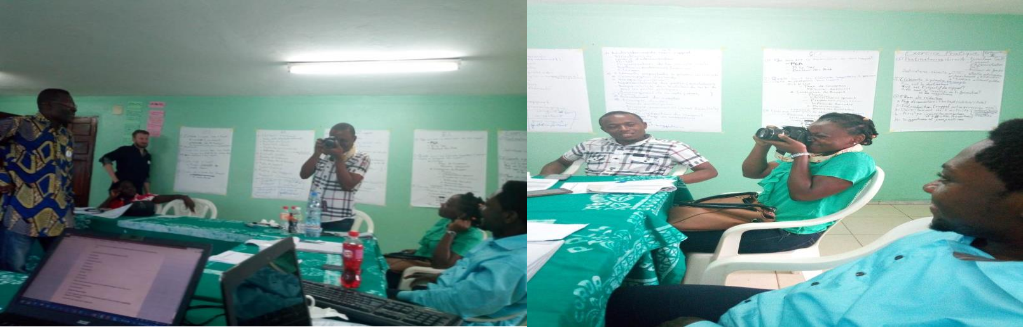
The most three important questions to understand when filming is: who, what, where

To show the filming situation
- Focus on the hands for security of The camera
- shoot through the shoulder

The “wow” Can be used when shooting serval aspects. This give the possibility to add more« focus creative.” We should note that one shot takes with seven “7” seconds to be realised.
- General plan
- Pan together
- Half-set plan
- Medium shot
- American plan
- A close-up
- Big plan
- Very close up
- The security aspect. Here we were taught how to handle a camera while taking pictures and what positions are appropriate in managing a camera.
- Types of Support:Analoqique and Numerics
- Types of Cameras: Compact and reflex (for professionals.)

For security reasons, you should tie it well round the hand or on the neck before taking the snap shot.

Module 3
PICTURE TAKING FOR WEBSITE AND
FOR DOCUMENTSARCHIVES
- BASIC PRINCIPLE OF SHOOTING TECHNIQUES

- GROUP PRACTICAL EXERCISE

- THE 5 SHOTS

GENERAL REMARKS

The participants greatly appreciated the training program as it is a tool that will be used for the internet of SeP organisation.

For some, they had a good knowledge of certain things but have learned so many new things. As for the others, they were just jotting without knowing and they believe it will not serve only for writing articles at SeP but out of SeP equally and other areas. Shed ended by thanking the facilitator for their availability to dispense this course.

Then presenter took the floor to know whether the expectations were attained. He appreciated the program and proposed that their organisation is open for dialogue and wishes that everyone should feel free to call and send a mail if there is need for any clarifications.

The session ended with a word from the Director of SeP who thank DMJ for the wonderful partnership, the work done to reinforce the partnership and wishes that such a partnership should last for longer times and keeps on moving smoothly. He reiterates the fact that the training will not be wasted or underused but will be put into practise thereby producing good results in time and days to come. The meeting finally ended at 05h 16mins PM

- FINAL CONCLUSIONS REMARKS AND RECOMMENDATIONS

RECOMMENDATIONS.

In light with some questions that were asked during the training session, one participant suggested that the materials exposed be given a copy each to the participants because this will permit the participants to go through the material again during their spare times so as to have a better understanding of some points which they did not really understand.

For another, she suggested that she wished such events were organised after a given frequency given its importance in the reinforcement of the capacities of the volunteers and Sep staff. She proposed that other sessions be organised on different topics so as to enrich the competence of the participants
Another participant mentioned the fact that he had no idea on the different types of shoots that existed but wishes that more practical exercises be organised on how to take pictures, with their different meanings and explanations so as to improve upon the type of pictures that will be taken to enrich SeP web sites.

Haven come to the end of this exercise which had as prime objectives to train and reinforce the capacities of the volunteering staff of SeP, on reports writing, article writing and picture shooting for the internet and SeP web site. After this session, all the participants were satisfied and their expectations were attained at a greater percentage, looking at some testimonies from participants who had some knowledge on reports wrting and picture taking but did not have all these details which they found very enriching. Despite the heavy program with the limited amount of time. It was very enriching and promising. From these observations it will be deem necessary to outline that training programs to reinforce capacities of SeP volunteering staff is very important given that the Director is forming a good staff that will assist him run effectively he’s day to day activities to perfection and effectiveness.

- FINAL CONCLUSION

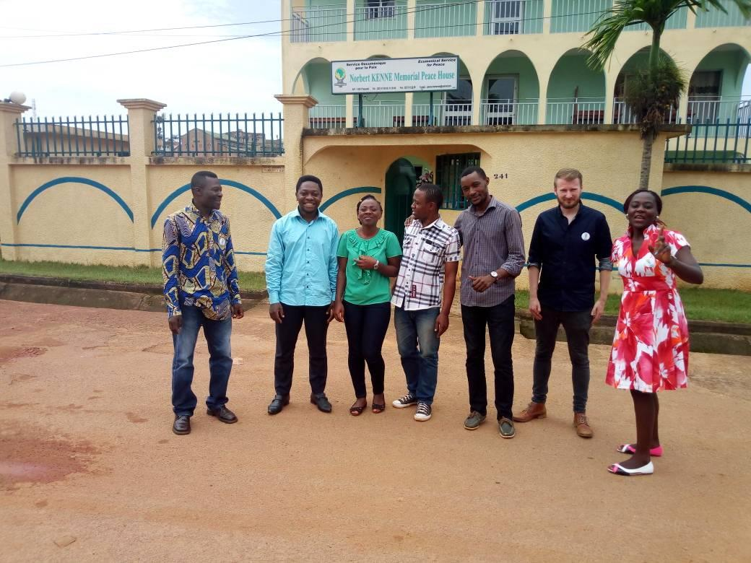

L’ATELIER DE FORMATION SUR LES TECHNIQUES D’ANIMATION

INTRODUCTION

Dans la dynamique de renforcement des capacités de ses volontaires, le Service Œcuménique pour la Paix (SeP) à la demande de son directeur, a organisé le 30 Août 2018 à son siège une session de formation sur les techniques d’animation des ateliers. Conviés au sein du Norbert Kenne MemorialPeace House, dans la salle Desmond Tutu, quatorze participants comprenant l’équipe du SeP et les formateurs de la Dynamique Mondiale des Jeunes (DMJ) ont répondu présents. Il s’est agi au cours de cette formation de renforcer les capacités de l’équipe du SeP en techniques d’animation d’un atelier afin de pouvoir monter et animer des ateliers à caractère social ou scientifique au profit des jeunes.

DEROULEMENT DE L’ACTIVITE
La formation était principalement axée sur dix (10) présentations divisées en trois (03) modules effectuées par les formateurs de la DMJ.
- Premier module

- Présentation
La première présentation était centrée sur les principes généraux d’animation des ateliers dans lequel la définition d’un animateur a été appréhendée comme un individu qui amène le groupe par des astuces diverses à atteindre des objectifs et de cheminer ensemble. Etant donné que l’animation c’est donner vie, l’animateur est celui-là qui coordonne et contribue à la réalisation d’une activité et pour ce faire, il doit étudier le milieu (le groupe, les comportements, les faiblesses), se préparer, s’adapter, être exemplaire, savoir confier des responsabilités. Cette définition a permis de saisir quelques synonymes d’un animateur qui sont : un facilitateur, « communicateur », modérateur, un organisateur, un régulateur, un manipulateur, un coach et un gestionnaire de temps et d’espace. Notons qu’il existe deux (02) types d’animations; celle dite globale qui est générale et l’animation orientée (Exemple: techniques d’animation des ateliers…).

- Présentation
Cette dernière concernait la préparation d’une animation. A ce niveau, il y a quatre (04) types de préparation: la première dite intellectuelle qui consiste à évaluer ses ressources à la lumière des objectifs à atteindre. A cette étape, il faudrait définir des objectifs et des cibles; faire une analyse de contexte (us, coutumes, habitude); réfléchir aux moyens humains, matériels et financiers; établir une méthodologie de travail et enfin avoir un suivi et une évaluation. Ensuite, vient la préparation matérielle qui est le matériel didactique de l’animateur pour donner vie à son activité, il se scinde en matériel de visualisation et de capitalisation. La répartition des rôles est le troisième type très important auquel l’animateur doit recourir parce qu’il permet de définir avec précision les rôles des acteurs avant, pendant et après l’activité. Dans le contenu, on définit la méthodologie spécifique propre à chaque module. En outre, tous ces types doivent se trouver dans les termes de référence (TdR).

- Présentation
Cette présentation est relative au rôle de l’animateur et styles d’animation. Ici, le rôle de l’animateur se définit à quatre (04) niveaux à savoir:
- au premier niveau: l’animateur joue le rôle de producteur et de régulateur qui est une relation descendante dans laquelle, il attribue des responsabilités à ses collaborateurs et veille à leur réalisation;
- au second niveau: elle est une relation ascendante qui est fonction de proposition dans la mesure où, l’animateur bien que collaborateur fait des propositions par rapport à un sujet donné à son hiérarchie pour obtenir validation;
- au troisième niveau: l’animateur joue le rôle de facilitateur car il facilite non seulement les échanges entre les participants, mais contribue également à la bonne compréhension par tous. On parle de relation horizontale.
- au quatrième niveau: l’animateur joue un rôle à tous les niveaux car il est fonction de gestion de la motivation, de communication et d’analyse de contexte.
De cette présentation, l’on peut retenir qu’il n’y a pas un style d’animation qui soit foncièrement mauvais mais que chacun applique la méthode qui lui réussit le mieux. A côté de ceci ce greffe les styles d’animation ou de leadership qui sont: le style autoritaire où l’animateur impose ses idées, le style démocratique qui est participatif et inclusif, le laissez-faire qui est un style qui dépend fortement du niveau de compétence et de la volonté des participants, et enfin le style relationnel qui s’implique dans les trois autres styles essentiellement dans celle dite démocratique.

- présentation
Cet axe intitulé règles de base en animation faisait état des différentes postures et comportement d’un bon animateur. L’accent a été mis sur certains éléments à savoir: être à l’écoute et attentif avant de communiquer, intervenir avec bon sens dans les discussions, être sûre de lui mais humble, être capable de captivé l’attention via des blagues ou des illustrations et savoir remercier et valoriser les participants. En outre, il a été établi qu’il faut s’exercer pour animer un atelier.

- présentation
En ce qui concerne ce point relatif aux outils de l’animation, il ressort que les différents équipements et matériels à utiliser pour animer une activité tel qu’un atelier sont des blocs notes, des stylos, matériels de visualisation, le programme qui intègre clairement l’assignation des tâches. Il doit aussi avoir le kit du participant, la liste de présence, le terme de référence et un récépissé de déclaration. L’animateur comme outil devrait avoir une bonne voix.

- présentation
Les participants ont également été édifiés sur les dispositions de la salle et les effets que cela pourraient avoir sur les résultats. L’arrangement de la salle doit tenir compte de la forme de la salle, du nombre de participant et de l’objectif que l’animateur souhaite atteindre. Ces différents types de disposition sont: disposition en rang, en U mais avec une table, en U creux, en arête de poisson et en cercle. La disposition est importante dans l’animation dans la mesure où elle influence fortement le déroulement de l’animation de même que la manière dont les participants venant d’horizons diverses se comporteront.

- présentation
Ce point portait sur le rôle de l’évaluation de départ. C’est la collecte des attentes et des craintes des participants dès le début de l’activité. Cet exercice de collecte est bénéfique pour les participants en ce sens qu’elle permet que ceux-ci soient imprégnés du thème, d’avoir une idée de ce qui sera dit, permettra de les mettre en confiance et pour l’animateur dans la mesure où, ça lui permettra de mieux orienter et de canaliser la communication. Mais elle peut prendre assez de temps si les participants sont nombreux.

- présentation
Cette présentation faisait allusion aux différentes approches ou stratégies d’animation des groupes et des étapes à suivre dans leurs applications. Ces stratégies sont: les principes de base du leadership, la doctrine sociale de l’Eglise Catholique Romaine, la règle du 3P, la loi du moindre effort, l’approche pédagogique interpersonnelle et l’approche globale des réunions encore appelée tempête des cerveaux. Notons que toutes ces approches s’accompagnent de l’action qui ne se limite ni à une tâche, ni à une activité mais est une entité qui se prépare, se réalise et s’évalue.

2. Deuxième module

- présentation
Cette dernière était centrée sur quelques techniques de brise-glace qui s’appréhendent comme étant une activité pratique mettant en mouvement et en relation les participants et ayant pour objectif de faire tomber les barrières entre participants. Quelques exemples de ces « enegizers » sont: les mimes, la danse des chaises, jeu des enchevêtrements, «awara», petit canard, la lumière, les desseins et la salutation des épaules. De la même manière que ces jeux détendent l’atmosphère, ils favorisent la connaissance mutuelle, ils permettent de se rapprocher et de se relaxer; il y a également des risques de se faire mal et de frustrer des personnalités non habituées. En sommes, pour la réalisation efficace de cette technique d’animation il faut impérativement tenir compte de l’environnement social.

- présentation
Elle portait sur les indicateurs d’une bonne animation qui ne sont rien d’autres que la réinterprétation positive des idées et l’implication non discriminatoire des participants. En fait, il s’est agi de donner une action et un qualificatif précis qui pourrait qualifier un animateur après une animation.

3. Troisième module

ANALYSE DE L’ACTIVITE

Les quatorze personnes conviées à la formation ont répondu présents. Les participants ont manifesté beaucoup d’intérêt pour la formation d’où les questions pertinentes posées à l’endroit des animateurs et les multiples contributions apportées. Les réponses aux différentes préoccupations et présentations des facilitateurs n’ont pas seulement permis de valider les attentes des apprenants mais a aussi diminuer leur inquiétude qui étaient de maitriser et d’appliquer au moins une technique d’animation et la peur que le message ne soit pas bien transmis.

Les apprenants ce sont soumis à un travail de groupe dans lequel il était question pour ceux du groupe de préparer la logistique à utiliser en vue de la préparation d’un atelier de planification stratégique du SeP et de justifier le choix. Les membres du groupe II quant à eux ont travaillés sur la répartition des rôles avant, pendant et après la même activité. Les remarques faites à la fin de ce travail par les animateurs étaient constructives. Ils ont fait comprendre que l’animation se passe à tout moment lorsque nous sommes en situation de responsabilité. De ce fait, il faut faire preuve de créativité et d’imagination.

Si le contenu de la formation a eu une bonne résonnance, le facteur temps n’a néanmoins pas été respecté par certains participants. En effet, l’arrivée tardive de ces derniers a créé un décalage horaire dans toutes les articulations de l’atelier. Toutefois, son caractère intéressant et les prouesses saluées les animateurs ont pallié cette insuffisance.

CONCLUSION

Parvenu au terme de ce rapport, nous pouvons retenir que l’animateur est un individu polyvalent, avec une vision panoramique et une immense capacité d’anticipation qui lui permettra de pallier aux situations indésirables qui surviennent. Cela lui permet de comprendre les besoins des membres du groupe, de présenter les règles de fonctionnement de l’activité qu’il est appelé à coordonner. De même, il doit être à mesure de mettre à disposition ces outils de travail, de synthétiser le contenu des échanges et aussi, de choisir et expliquer la méthode de travail utilisée. Pour donner vie où il se trouve, tout animateur doit veiller à réunir ces conditions préalables et réviser ces techniques.

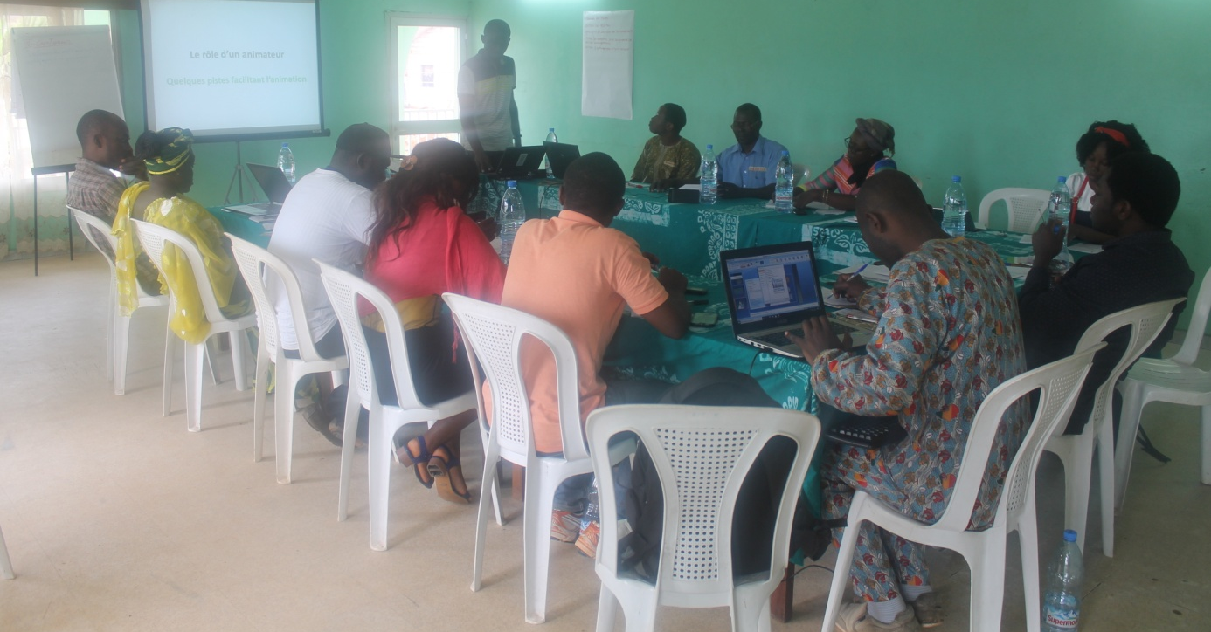
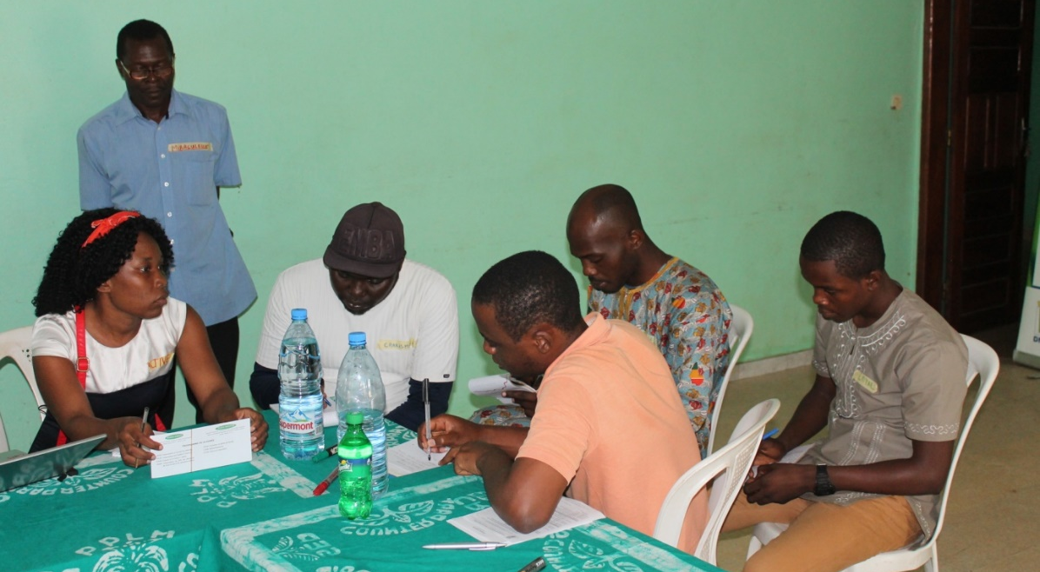

L’ATELIER DE FORMATION SUR DES LOGICIELS EXEL ET POWERPOINT

INTRODUCTION

Dans le but de renforcer les capacités de son équipe de travail, le Service Œcuménique pour la Paix (SeP) à la demande de son directeur, a organisé le 30 Octobre 2018 à son siège une session de formation sur la connaissance et la manipulation des logiciels Excel et Powerpoint. Conviés au sein du Norbert Kenne MemorialPeace House, dans la petite salle de conférence, six participants et un facilitateur du Service Œcuménique pour la Paix (SeP) ont répondu présents. Il s’est agi au cours de cette formation de renforcer les capacités de ses volontaires sur les logiciels Excel et Powerpoint. Ceci dans le but d’être à même d’effectuer aisément des calculs et de monter, d’animer une présentation dans divers activités qu’elles soient à caractère social, éducatif ou scientifique au profit des jeunes. Mais aussi, pour leur apprentissage personnel.

- présentation
Cette présentation était centrée sur la connaissance de l’interface Excel dans laquelle Excel a été définit comme un logiciel dit « tableur » ou « classeur » très utilisé en comptabilité qui permet de manipuler les feuilles de calcul. Ici, les fonctionnalités élémentaires de son application telles que les pré-requis sur Windows ont été apprivoisées dans l’exposé fait par le facilitateur. Il a été enseigné des choses au travers des exercices comme : la création et l’enregistrement d’un classeur; l’ouverture et la fermeture d’un classeur; comment sélectionner des cellules et des tableaux ; copier et déplacer des tableaux et des cellules, et aussi écrire dans une cellule et modifier son contenu. Il s'est aussi agit de définir l’aspect des cellules de nos tableaux : appliquer des bordures, des couleurs ; jouer avec les formats de nombres. En somme, c’est la navigation sur Excel. Notons qu’il a été établit de ne pas rater une bulle ou une ligne au risque de se trouver bloqué.
- présentation
Cet axe intitulé les calculs simples dans Excel faisait allusion à l’utilisation des formules et comment copier et coller. Il ressort qu’il suffit de taper sur le signe égal (=) pour ajouter une formule, sur + pour l’addition, - pour la soustraction, * pour la multiplication et lorsqu’il s’agit de la division on tape sur /. Les parenthèses ( ) et deux caractères peuvent également être utilisés dans d’autres formules. On peut aussi effectuer une copie en tirant le coin inférieur droit de la cellule. La maitrise de la recopie de formules et la capacité d’optimiser la copie de formule grâce aux références relatives, absolues et mixtes en vue de solliciter deux fois la mémoire des participants étaient les objectifs recherchés de cette présentation. En effet, il se faisait via la prise de temps de lecture de toutes les instructions et leur exécution immédiate. Pour une bonne maitrise des principes de calcul, l’animateur a donné des exercices d’applications pratiques et individuelles au fur et à mesure pour connaitre le niveau de compréhension de tous les participants.
- présentation
En plus des formules et calculs simples, Excel prévoit des fonctions prédéfinies pour simplifier le travail. Ces fonctions sont : SOMME, SOMME.SI, MOYENNE, MAX (maximum), MIN (minimum), NB (nombre de…), la devise (changer une monnaie à une autre) et la mise en forme conditionnelle. Elles ont tous des syntaxes prédéfinies et permettent d’exécuter des actions selon des conditions que vous définirez. La maîtrise des références absolues et relatives sont des pré-requis à partir de ce niveau.

DEROULEMENT DE L’ACTIVITE
La formation était principalement axée sur cinq (05) présentations divisées en deux (02) modules effectuées par le formateur du SeP. Le premier portant sur Excel et le deuxième sur Powerpoint.

- Premier module

- présentation
En ce qui concerne le point relatif à l’étude de quelques fonctions avancées, il fait état des fonctions complexes et de leurs utilisations. Elles sont les fonctions SOMME, SI, SOMME.SI et la mise en forme conditionnelle respectivement.

- La première fonction se trouve dans l’onglet formules, a trois (03) arguments et se dénote comme suit : = SOMME (A1; B1; C1). Ici, le signe égal indique automatiquement un calcul. Après vient le nom d’une formule ou d’une fonction, et dans la parenthèse, l’argument des adresses de cellules séparés par le point virgule ou par les deux points ;
- La seconde fonction est aussi à trois arguments et a la formule suivante :
= SI (A1>5; ‘‘grand’’; ‘‘petit’’). Dans ce cas, après le nom de la fonction vient le test logique, puis dans la parenthèse les arguments (ce qui arrive si c’est vrai ou si c’est faux) ;
- La troisième est une formule à trois arguments aussi. Elle s’écrit comme suit :
= SOMME.SI (A1:A20; ‘‘payé ’’; B1:B20). Le premier argument séparé par un point virgule dans la parenthèse est dit plage de recherche, l’argument du milieu et l’élément recherché et le dernier, plage additionnel ;
- L’utilisation d’un format conditionnel peut aider à explorer et analyser des données, à détecter des problèmes critiques et d’identifier des modèles et des tendances.

- présentation
Ce point portait sur la présentation de Powerpoint dans laquelle elle a été appréhendée comme un logiciel de Présentation Assistée par Ordinateur qui permet de préparer des présentations contenant du texte, des images, des effets visuels, du son. Notons qu’il offre trois (03) modes d’affichage principaux :

- Le mode Normal qui est le principal mode de modification utilisé pour écrire et concevoir des présentations et comprend trois zones de travail ;
- Le mode Trieuse de diapositives qui offre une vue d’ensemble de toutes les diapositives sous forme de miniatures et permet la réorganisation, l’ajout ou la suppression des diapositives, et de visualiser les effets de transition et d’animation ;

Le mode Diaporama occupe tout l’écran de l’ordinateur comme une véritable présentation. Il permet de pouvoir visualiser l’aspect des éléments graphiques, des minutages, des films, des éléments animés et des effets de transition du diaporama définitif

- Premier module

ANALYSE DE L’ACTIVITE

CONCLUSION

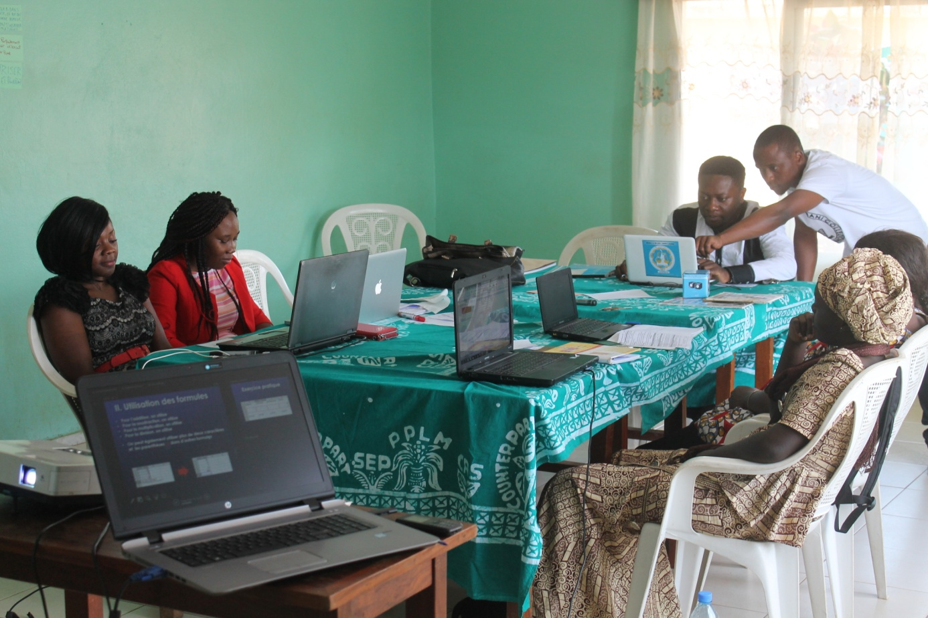

Les six personnes conviées à la formation ont répondu présents et ont manifesté beaucoup d’intérêt pour la formation parce que l’utilisation de ces logiciels étaient plus ou moins nouveau pour certains participants et pour d’autres un juste un renouvellement de connaissance. A cause de cette situation, le facilitateur a vraiment pris du temps pour palier aux insuffisances de tout un chacun non seulement au niveau des différents exercices pratiques, mais également sur les divers présentations en étayant mieux ses propos et en donnant des exemples palpables.
Les apprenants se sont soumis à un travail qui était à la base de groupe mais rendu individuel par l’animateur. Il était question pour chaque apprenant de concevoir une présentation dans Powerpoint sur la thématique de leur choix et de le restituer par la suite. Les différents exposé portaient sur : la famille, la belle histoire, les papayes ensoleillées, la philosophie 237 et la psychologie de l’habillement. Travail accomplis avec quelques petits bémols dans chaque présentation appréciée par le facilitateur et les participants. Il avait pour objectifs la conception des diapositives, l’animation des présentations et de faire preuve de créativité et d’imagination.
Si le contenu de la formation a eu une bonne résonnance, le facteur temps n’a néanmoins pas été respecté par certains participants. En effet, l’arrivée tardive de ces derniers et du projecteur a créé un décalage horaire dans toutes les articulations de l’atelier. Toutefois, son caractère intéressant et les prouesses saluées l’animateur a pallié cette insuffisance.

Parvenu au terme de ce rapport, nous pouvons retenir que ces Office Excel et Powerpoint sont des logiciels de travail conçues non seulement pour simplifier les calculs et les présentations respectivement des enseignants, comptables, mais également des conférenciers par exemple lors des exposés. Pour être capable d’effectuer aisément des calculs dans Excel et de monter une présentation dans Powerpoint, tout individu devrait sollicité deux fois sa mémoire car comme on le sait : la répétition est l’amie de la mémoire.

RAPPORT DE L’ATELIER DE FORMATION SUR LA CONCEPTION ET LA MISE EN ŒUVRE D’UNE ACTIVITE DE CAPITALISATION

INTRODUCTION

Dans le but de renforcer les capacités de son équipe de travail, le Service Œcuménique pour la Paix (SeP) à la demande de son directeur, a organisé le 02 Novembre 2018 à son siège une session de formation sur comment concevoir et mettre en œuvre une activité de capitalisation. Conviés au sein du Norbert Kenne MemorialPeace House, dans la petite salle de conférence, quatre participants et un facilitateur du Service Dynamique Mondiale des Jeunes (DMJ) ont répondu présents. Il s’est agi au cours de cette formation de renforcer les compétences de l’organisation en matière de capitalisation des expériences afin que les participants comprennent l’intérêt et l’importance d’une démarche de capitalisation.

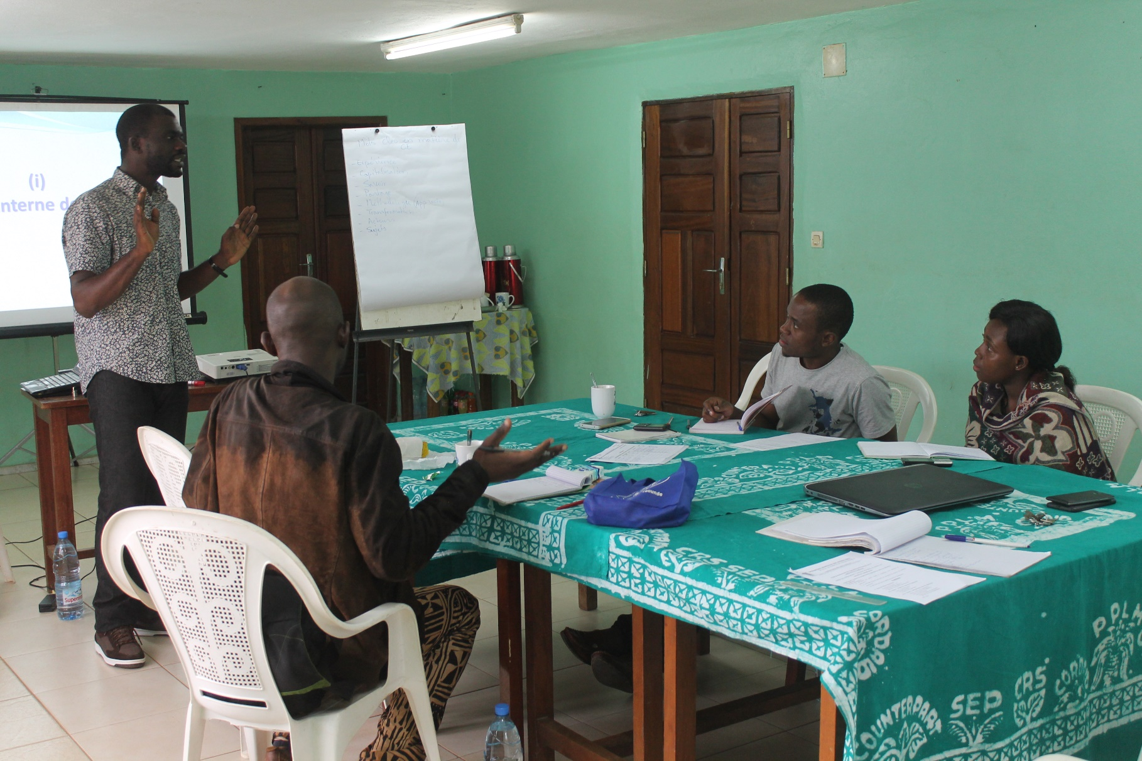

DEROULEMENT DE L’ACTIVITE
La formation était principalement axée sur deux (02) modules effectués en quatre présentations par le formateur de la DMJ.
Premier Module - Objectifs et enjeux de la capitalisation

La capitalisation d’expérience encore appelée knowledge management a été définit par Pierre de Zutter comme la transformation des savoirs en connaissances partageables. Elle est perçue dans ce cas en termes d’organisation et non d’individu, ayant pour enjeu le gain. Cette définition a permis de saisir quelques mots clés en matière de capitalisation d’expérience sont : l’expérience, la capitalisation, le savoir, la méthodologie (l’approche), la transformation, les acteurs, les sujets et le plus important le partage (faire savoir).

- présentation
La première présentation était centrée sur la gestion interne des savoirs, le partage d’expérience et la promotion de l’organisation respectivement. Le but visé à travers la capitalisation d’expérience est de répondre à un ou plusieurs besoins tournant autour du rendement et de la satisfaction durable et maximale des bénéficiaires. Notons que le processus de capitalisation (la pérennité et la continuité) d’une organisation a des étapes à savoirs :
- La théorisation et la modélisation du savoir-faire acquit pour ne pas les perdre en cas de changement de collaborateur ;
- La transformation des connaissances tacite (non organisées) en connaissances explicite (structurée – éprouvée) ;
- Se donner les clefs pour préparer l’avenir et anticiper sur les activités et les résultats visés;
- Valoriser son savoir-faire pour progresser dans sa fonction et sa carrière professionnelle ;
- Communiquer aux cibles, aux bailleurs, aux paires, aux gouvernements, aux chercheurs… sur ce qu’on réalise.
En outre, toute activité de capitalisation influence toujours à la fois l’organisation et l’individu.

- présentation
Cette dernière concernait l’initiation d’un processus de capitalisation. A ce niveau, il y a cinq (05) étapes qui conduisent à ce processus. La première est celle de l’identification des besoins de l’organisation où l’on doit répondre à la question que veut-on capitaliser ? Ensuite, nous devons être capables de définir ses objectifs en se posant la question de savoir à quoi va servir l’outil de capitalisation ? Puis suit l’identification des cibles (à qui veut-on s’adresser ?) La quatrième étape est celle de choisir son support de capitalisation, c’est-à-dire de concevoir un produit adapté pour garantir un impact et ce fait uniquement par le biais de la communication. Planifier son action de capitalisation est la dernière étape à suivre dans l’initiation de ce processus.
- présentation
Cette présentation est relative à la production d’un support de capitalisation. Il s’agit ici de faire l’inventaire de la documentation dont on dispose déjà et d’identifier les besoins pour la production du support C’est l’étape de la collecte des informations. Le côté pratique, attirant, la façon de montrer son savoir-faire et son professionnalisme entre dans la conception de ce support. Notons que pour produire un support de capitalisation en bonne et due forme, il ne faut pas hésiter à renforcer son équipe de travail avec par exemple un infographe, un réalisateur, voir des artistes.

- présentation
Les participants ont également été édifiés sur la diffusion de son travail de capitalisation car elle fait partie de ce processus. Il ressort qu’il est important et nécessaire de communiquer, diffuser et partager son travail de différentes manières à travers l’organisation des présentations officielles et des ateliers de partages, par des projections, en le mettant en ligne par exemple. En sommes, le support de capitalisation ne doit rester dans des cartons mais sa diffusion devrait plutôt être planifiée et budgétiser

- Deuxième Module – Méthodologie et outils de capitalisation

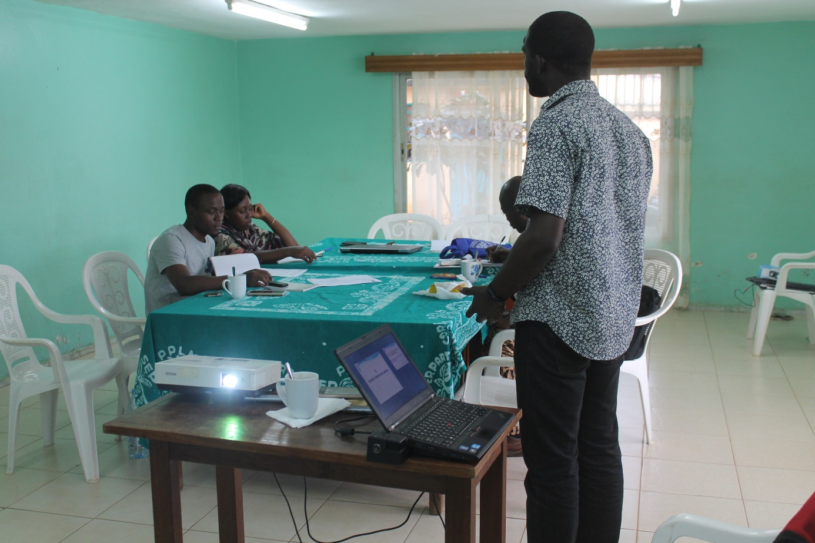

Les cinq personnes conviées à la formation ont répondu présents. Les participants ont manifesté beaucoup d’intérêt pour la formation d’où les questions pertinentes posées à l’endroit de l’animateur. Le facilitateur a vraiment pris du temps pour pallier aux inquiétudes des apprenants comme au début sur la polysémie de la notion de capitalisation, mais également sur les diverses présentations en étayant mieux ses propos et en donnant des exemples palpables. Les apprenants ce sont soumis à un travail de groupe dans lequel il était question pour eux premièrement de répondre à cinq questions qui avait pour intitulé outil d’aide à la conception d’une activité de capitalisation, et de par la suite continuer à remplir une fiche en précisant les tâches à effectuées, ses objectifs, les besoins pour l’exécution, les personnes impliquées et la période qu’aura lieu ces différentes tâches. Cet exercice avait pour objectifs la conception et la planification d’une activité de capitalisation à l’aide de ces outils, adopter un raisonnement logique et cohérent mais aussi apprendre à être parcimonieux.
Travail accomplis avec quelques bémols que le facilitateur a su apprécier. Si le contenu de la formation a eu une bonne résonnance, le facteur temps n’a néanmoins pas été respecté par certains participants du à la forte pluie. En effet, l’arrivée tardive de ces derniers au environ de 11h30 a créé un décalage horaire dans toutes les articulations de l’atelier qui s’est terminé vers 15h30. Toutefois, son caractère intéressant et les prouesses saluées l’animateur a pallié cette insuffisance.

ANALYSE DE L’ACTIVITE

CONCLUSION

Parvenu au terme de ce rapport, nous pouvons retenir que la capitalisation d’expérience c’est le savoir acquit par la pratique et/ou par l’observation. Elle a également une capacité adaptatrice à tout secteur de travail, au niveau organisationnel ou même individuel. La capitalisation s’appuie sur le postulat qui soutient que le savoir appartient et se trouve auprès des acteurs de l’action et le présupposé que le savoir des uns peut être utile pour d’autres. C’est-à-dire sans aucun doute que, l’expérience et le partage sont au cœur de cette activité et processus de capitalisation car nul n’a le monopole du savoir.

WORKSHOP AND CONFERENCE

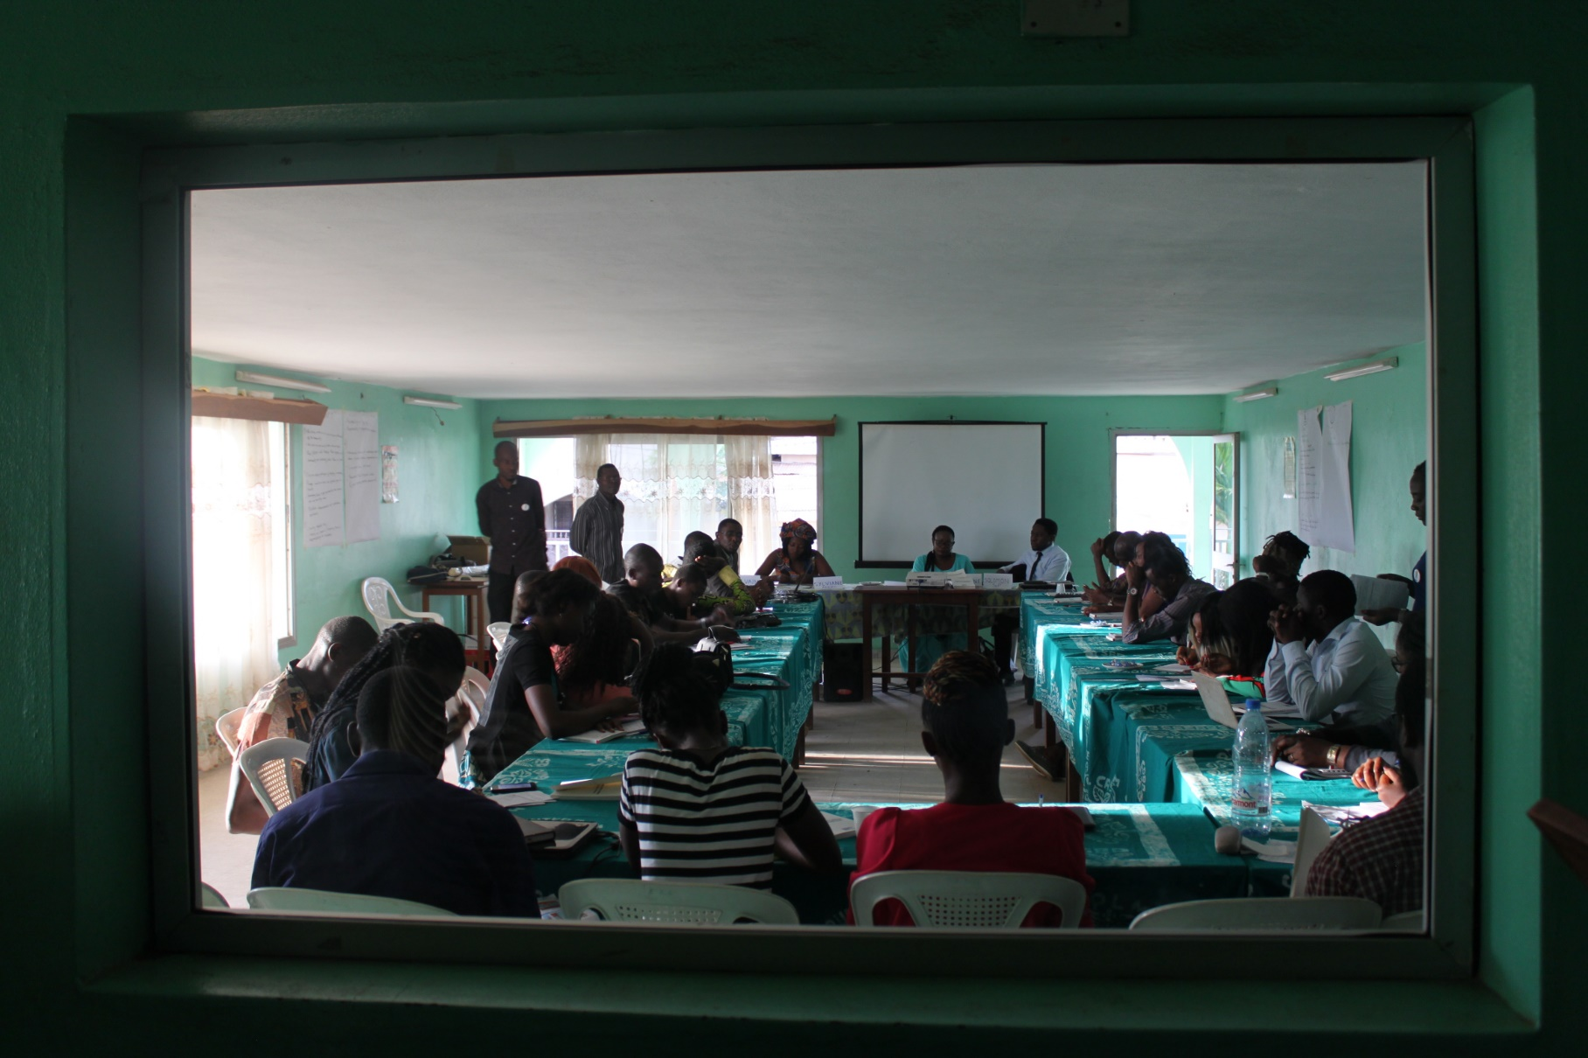

2. RAPPORT DE L’ATELIER POUR JEUNES
DEVELOPPEMENT ET PRATIQUE DE LA CITOYENNE ACTIVE

- RAPPORT DE LA CONFERENCE ITIE SUR LE THEME
« ETAPES ET DEFIS DE LA MISE EN ŒUVRE
DE L’ITIE AU CAMEROUN »

RAPPORT DE L’ATELIER POUR JEUNES
DEVELOPPEMENT ET PRATIQUE DE LA CITOYENNE ACTIVE
INTRODUCTION

Les citoyens ont un rôle à jouer pour bâtir une société meilleure, fondée sur la démocratie. Pour cela, il est fondamental d'acquérir les compétences et les attitudes propres à la citoyenneté active. Malheureusement, le concept de citoyenneté active reste confus voire inconnu par la plupart des camerounais du fait d’un manque d’intérêt et d’une incompréhension des enjeux et de l’importance de la question de citoyenneté. C’est ainsi que la Friedrich Ebert Stiftung en collaboration avec un groupe de réflexion ont produit un ouvrage intitulé «Citoyenneté active au Cameroun : Enjeux, Défis et Perspectives» qui vise à rendre effectif la citoyenneté active, créer et défendre les libertés civiles et politiques et ouvrir les institutions pour l’engagement citoyen plus fort.

L’organisation de cet atelier intervient pour répondre aux deux principales résolutions prise à l’issue de la présentation officielle de l’ouvrage « Citoyenneté active au Cameroun : Enjeux, défis et perspectives » à savoir : Diffuser l’ouvrage auprès de toutes les organisations partenaires et la recherche des actions à mener sur le terrain en tant que citoyen. Dynamique Mondiale des Jeunes (DMJ) et le Service Oecuménique pour la Paix (SeP) se sont associés pour répondre à ces deux défis en essayant d’élargir le nombre de jeunes devant prendre conscience de la responsabilité et de la volonté d’agir pour construire l’inclusion et la cohésion sociale, la solidarité et la fraternité nationale, qui sous-entendent pour nous, un souci pour chacun-e, de prendre des initiatives là où il/elle se trouve, de les assumer en rendant des comptes. L’objectif de cet atelier était donc de contribuer à l’éveil citoyen des participants en réfléchissant avec les jeunes sur les étapes et conditions leur permettant de prendre conscience de la nécessité d’agir positivement sur leur environnement à partir de leurs attitudes et aptitudes, de leurs expressions vivantes, de la mise en évidence de leurs expériences et de leurs initiatives individuelle ou collectives pour le bien-être des autres au sein de leur commune et communauté.

28 jeunes ont répondu présent à cet atelier dont 13 femmes et 15 hommes. Parmi ceux-ci, nous avons un musulman, 21 chrétiens (dont 9 catholiques, 5 protestants, 1 baptiste, 1 pentecôtiste) et 5 jeunes qui n’ont pas donné leur obédience religieuse. Ils ont des profils divers, allant des étudiants des grandes écoles, les journalistes, jeunes entrepreneurs, les jeunes professionnels exerçants dans les métiers de la communication et l’enseignement et membres des organisations de la société civile.

DEROULEMENT DE L’ACTIVITE

1 . INFORMATIONS SUR LES PARTICIPANTS

2. RÉSUMÉ DES COMMUNICATIONS DU PANEL

- What is active citizenship?
Cette partie a été présentée par Solomon Fomunkong, Directeur du Service Œcuménique pour la Paix (Sep). Dans cet exposé introductif, il était question d’expliquer le concept de citoyenneté et celui de citoyenneté active. Ensuite, d’établir les responsabilités d’un citoyen actif dans la société, présenter les causes de la passivité des camerounais et les moyens pour promouvoir la citoyenneté active.

- Jeunesse et Citoyenneté active Cameroun
La présidente de la DMJ auteur de ce chapitre a entamé sa présentation par une définition des concepts tels que jeunesse et citoyenneté active. Elle a ensuite présenté le cadre réglementaire et la mise en œuvre de la citoyenneté active des jeunes au Cameroun. Elle a fait une analyse prospective des difficultés dans l’expression de la citoyenneté chez les jeunes au Cameroun et enfin, elle a présenté quelques perspectives.

- Obstacles à l’engagement citoyen au Cameroun
Cette partie, représentant le chapitre 2 de l’ouvrage a également été présenté par son auteur Kapchie Sylvianne membre de l’Association pour la Défense des Droits des Etudiant(e)s du Cameroun (ADDEC). Elle est revenue sur l’état des lieux de l’engagement citoyen au Cameroun, ensuite les obstacles à l’expression citoyenne que sont l’administration, le système judiciaire, les médias, les forces de l’ordre et l’armée, les chefferies traditionnelles, la famille et le milieu scolaire. Présentant les facteurs qui favorisent la passivité des citoyens, elle a relevé les facteurs d’un point de vue historiques et culturels.

- Passer de l’information à la citoyenneté active
La présentation de cette partie a été faite sur trois principaux points. Tout d’abord le citoyen et l’information dans le contexte camerounais. Il était question de s’interroger sur l’accès à l’information catalyseur de la citoyenneté active, les obstacles à l’accès aux informations au Cameroun et les différents types d’information utiles au plein exercice de la citoyenneté. Ensuite, comment passer de l’information à l’action dans le contexte camerounais et enfin de l’information à l’action : quelques modalités opérationnelle en 4 étapes clés que sont : l’information- la formation - l’organisation et l’action.

3. TRAVAUX DE GROUPES ET RESTITUTIONS
Les jeunes se sont regroupés en quatre groupes pendant une durée déterminée pour apportés les réponses aux questions posées en apportant des plusieurs recommandations.

GROUPE 1

- Qu’est ce qu’un citoyen actif?
- Un citoyen actif est celui qui participe au développement de sa communauté ;
- Un citoyen actif est celui qui prend soin des biens publics ;
- C’est celui qui connait ses droits et devoirs dans sa communauté et les met en pratique.

- Comment se traduit la citoyenneté dans votre quartier ou au sein de votre Commune?
- L’engagement dans le volontariat ;
- Les actions humanitaires par les groupes de vigilance ;
- Sensibilisation des jeunes sur les inscriptions sur les listes électorales et le vote ;
- La dénonciation des troubles à la sécurité.

- Quelles sont quelques responsabilités du citoyen actif que vous connaissez?
- Le devoir de voter ;
- La liberté d’expression ;
- La responsabilité de sensibilisation ;
- Payement des taxes ;
- Le respect des institutions de l’Etat.

- Qu’est ce qui peut être fait pour améliorer ou renforcer la citoyenneté active au sein de la jeunesse?
- L’éducation de la jeunesse sur les institutions à l’école, dans les organisations, à la maison, à l’église et autres milieux de socialisation ;
- Encourager les jeunes aux actions sociales ;
- Faire la promotion des valeurs.

- Quels sont les espaces ou cadres de participation et d’expression dont dispose la jeunesse pour manifester la citoyenneté active ?
- L’écocitoyenneté ;
- Les établissements d’enseignement ;
- Les médias et les réseaux sociaux ;
- Les églises et associations, clubs et mouvements de jeunesse ;
- Les partis politiques ;
- Les syndicats.

- Pourquoi selon vous peut-il être difficile pour la jeunesse au Cameroun d'exercer la citoyenneté active?
- Le manque de confiance en soi ;
- Le manque d’esprit de volontariat ;
- Les répressions policières et administratives ;
- Faiblesse des formations en politique ;
- La corruption généralisée en particulier dans le système judiciaire ;
- La faible visibilité des citoyens modèles.

- Quelles suggestions pouvez-vous faire à la jeunesse camerounaise pour qu'elle développe la citoyenneté active ?
- Promotion de l’éducation civique et la bonne moralité ;
- Sensibilisation des jeunes sur les notions d’intégration nationale ;
- Promotion de l’auto-emploi ;
- Amélioration du système judiciaire et administratif ;
- Formation des jeunes sur les notions de Paix ;
- Promotion du volontariat ;
- Accepter les différences et promotion du vivre ensemble.

GROUPE 2

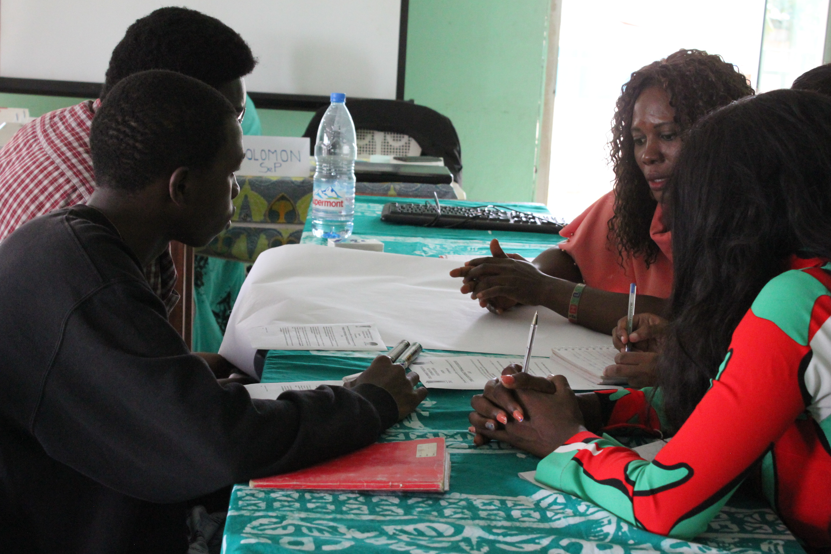

- Quels sont les obstacles que vous et d’autres jeunes de votre entourage rencontrez en voulant être ou devenir des citoyens actifs ?
- La méfiance des parents/ pression et contrôle exercés par les parents sur les enfants ;
- Les obstacles administratifs / influences de ceux-ci ;
- Manque de confiance chez les jeunes.

- Qu’est ce qui peut favoriser l’engagement citoyen des jeunes autour de vous?
- Soutien et encouragement de la famille ;
- L’implication des jeunes dans la chose publique ;
- Transparence dans le financement des projets dédiés aux jeunes ;
- Respect des droits de l’homme et des lois par le gouvernement.

- Quelles suggestions ou recommandations feriez-vous aux dirigeants camerounais pour qu'ils rendent favorable la pratique de la citoyenneté active chez les jeunes?
- Respect des lois
- Amélioration de l’offre de la qualité éducative ;
- Prise en compte des recommandations des Organisations de la société civile (OSC) ;
- Valorisation des héros et modèles nationaux ;
- Une véritable implication/un engagement renforcé des jeunes à la vie politique et aux projets sociaux ;
- Formation des jeunes à la citoyenneté active.

GROUPE 3

GROUPE 4

- Quels sont les principaux canaux auxquels la jeunesse camerounaise fait recours pour exercer son engagement citoyen? Et quelles sont leur limites?
- Les réseaux sociaux
- Les associations/ ONG
- Par contre ces canaux sont confrontés à quelques limites :
- L’information est douteuse
- Non contrôle des réseaux sociaux
- Limites financières pour l’accès à certains médias

- Quelle peut être l'importance de l'information dans l'exercice ou la pratique de la citoyenneté active au Cameroun?
- L’information a une importance capitale : chaque citoyen doit être au courant de ce qui se passe dans sa société pour pouvoir être plus actif et y participer.

- Parmi les canaux de communication que vous connaissez, lesquels sont les moins accessibles à la jeunesse camerounaise dans l'exercice de leur engagement citoyen? Pourquoi?
- L’accessibilité due au coût très élevé ;
- Non confiance de la part des jeunes envers les médias.

- Comment la jeunesse camerounaise peut-elle mieux utiliser la Radio comme espace de pratique de la citoyenneté active?
- Faire des annonces ;
- Des débats ;
- Faire des sensibilisations ;
- Multiplier des débats éducatifs et sociopolitiques.

Se référant aux résultats escomptés de départ, nous pouvons dire que cet atelier a permis une large diffusion de l’ouvrage et une meilleure compréhension du concept de Citoyenneté active.
Concernant le programme Impacting Your Generation, les jeunes ont fait plusieurs propositions sur le contenu et le déroulement de l’émission :
- Quatre jeunes se sont désignés pour animer l’émission. Ces jeunes constitueront le panel de l’émission qui portera sur la citoyenneté active.
- Un groupe Whatsapp des jeunes présents à l’atelier sera créé pour faciliter l’animation de l’émission et discuter de son contenu ;
- Rechercher les jeunes qui ont un talent (poète, slameur, artiste,...) et faire leur promotion lors des émissions ;
- Faire la promotion de l’émission via les réseaux sociaux ;
- L’émission doit être un moment de formation et d’éducation ;
- L’émission doit être un espace de promotion des modèles ;
- Produire un Pressbook des jeunes talents et suivre leur évolution ;
- L’émission doit être un lieu de diffusion des opportunités.
Au regard de toutes ces propositions faites par les jeunes, le contenu de l’émission subira quelques réajustements.

L’atelier a aussi servi d’espace de partage d’informations pratiques. C’est ainsi qu’une jeune participante du nom de Biloa a listé quelques chaines de radio où il est possible de faire passer une information gratuitement que sont : (Kiss Fm, Radio campus, Royal Fm, Maison de la radio).

4. RÉSULTATS OBTENUS

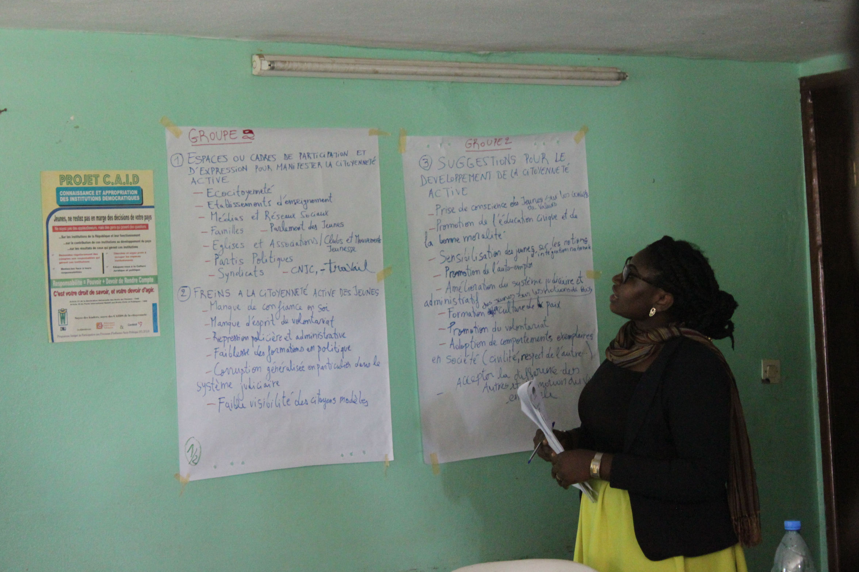

4. RÉSULTATS OBTENUS

Se référant aux résultats escomptés de départ, nous pouvons dire que cet atelier a permis une large diffusion de l’ouvrage et une meilleure compréhension du concept de Citoyenneté active.
Concernant le programme Impacting Your Generation, les jeunes ont fait plusieurs propositions sur le contenu et le déroulement de l’émission :

- Quatre jeunes se sont désignés pour animer l’émission. Ces jeunes constitueront le panel de l’émission qui portera sur la citoyenneté active.
- Un groupe Whatsapp des jeunes présents à l’atelier sera créé pour faciliter l’animation de l’émission et discuter de son contenu ;
- Rechercher les jeunes qui ont un talent (poète, slameur, artiste,...) et faire leur promotion lors des émissions ;
- Faire la promotion de l’émission via les réseaux sociaux ;
- L’émission doit être un moment de formation et d’éducation ;
- L’émission doit être un espace de promotion des modèles ;
- Produire un Pressbook des jeunes talents et suivre leur évolution ;
- L’émission doit être un lieu de diffusion des opportunités.

Au regard de toutes ces propositions faites par les jeunes, le contenu de l’émission subira quelques réajustements.

L’atelier a aussi servi d’espace de partage d’informations pratiques. C’est ainsi qu’une jeune participante du nom de Biloa a listé quelques chaines de radio où il est possible de faire passer une information gratuitement que sont : (Kiss Fm, Radio campus, Royal Fm, Maison de la radio).

5. EVALUATION FINALE
La fiche d’évaluation finale transmises aux jeunes comportait 3 principales parties dont : l’identification des participants, l’appréciation de l’atelier et l’utilisation des acquis de l’atelier. La première étant déjà analysée, nous nous appesantirons sur les 2 dernières.
- L’appréciation de l’atelier
Variables | Médiocre | Passable | Assez bien | Bien
Accueil et logistique (salle, matériel et accueil) |  | 4 | 10 | 11
Pertinence de l’atelier |  |  | 6 | 20
Pertinence contenu des présentations |  |  | 5 | 21
Performance des facilitateurs |  | 2 | 11 | 12
Niveau général de Participation |  | 3 | 6 | 16
Respect du timing | 2 | 9 | 9 | 6
Conditions et ambiance générale des travaux |  | 1 | 9 | 15

- L’utilisation des acquis de l’atelier

A la question de savoir, quelles actions citoyennes pensez-vous promouvoir ou mener dans votre commune/localité pour impacter positivement votre environnement ?
Les participants ont donné 5 principales réponses que nous allons énumérer par ordre décroissant à savoir : la sensibilisation des jeunes sur leur participation aux activités dans leur communauté, la promotion de l’écocitoyenneté, la promotion du volontariat, l’éducation des jeunes sur les questions électorales (l’inscription et le vote), amener les jeunes à participer à des plates formes de réflexion telles que les ateliers et afin faire la promotion de l’émission Impacting your generation.

Concernant de la deuxième question : quelles actions entrevoyez-vous de mener au sein de l’organisation à laquelle vous appartenez pour promouvoir la citoyenneté active ? La plus part des jeunes a proposé monter des projets de développement communautaires pour le bien être de la jeunesse. Ils ont également proposé d’organiser des ateliers de sensibilisation sur la citoyenneté active et faire la promotion de l’ouvrage. Mener les actions de promotion du vivre ensemble et de l’éducation civique et morale.
S’agissant de la dernière question portant sur le type d’accompagnement qu’ils désirent pour mener ces actions, les jeunes ont sollicité un accompagnement en termes de facilitateur et du coaching personnel pour renforcer leurs capacités c'est-à-dire bénéficier des facilitateurs de DMJ dans le domaine de la citoyenneté et Paix lors de leurs activités. Ils aimeraient d’ailleurs travailler en partenariat avec DMJ lorsqu’ils organisent un évènement. Ils désirent également bénéficier d’un soutien médiatique (participer à l’émission Impacting your generation pour promouvoir leurs talents et les activités). Et enfin un accompagnement managérial, matériel, financier (Ils n’ont pas été précis).

RAPPORT DE LA CONFERENCE ITIE SUR LE THEME
« ETAPES ET DEFIS DE LA MISE EN ŒUVRE
DE L’ITIE AU CAMEROUN »

INTRODUCTION

Dans le cadre de la consolidation de la mise en œuvre de l’ITIE au Cameroun, les organisations de la société civile se sont regroupées le Jeudi 21 Juin 2018 au siège du Service Œcuménique pour la paix pour discuter sur les « étapes et défis de la mise en œuvre de l’ITIE au Cameroun ». Conviés au sein du Norbert Kenne Memorial Peace House, dans la salle Desmond Tutu, une soixante de leaders de la société civile et d’entreprises ont participé aux échanges sur la thématique. Il s’est agi au cours de cette conférence d’amener les participants à informer le public sur l’initiative, pour qu’il y ait une meilleure compréhension et une mise à jour au sujet de l’avancement de la mise en œuvre de l’ITIE au Cameroun.

DEROULEMENT DE L’ACTIVITE

La conférence était principalement axée sur six présentations effectuées par les membres du comité et du secrétariat technique de l’ITIE.

- présentation
La première présentation était centrée sur la définition de l’ITIE, qui a été appréhendée comme une norme internationale pour la transparence dans les industries extractives. Parlant de son historique, il a été révélé que l’initiative fut créée par le premier ministre britannique Tony Blair lors du sommet mondial sur le développement durable en 2002 ; et qu’elle était une solution au paradoxe observé chez les pays qui exploitaient des ressources minières, mais demeuraient cependant dans la pauvreté. Ce qui a permis de saisir son rôle qui est de rassembler dans un rapport les données communiquées par les entreprises et par le gouvernement sur l’exploitation des ressources, et de les mettre à la connaissance du public ; d’où ses multiples avantages pour les citoyens, le gouvernement et les entreprises.
- présentation
Le second point concernait l’évolution et les résultats de la mise en œuvre de l’ITIE au Cameroun. A ce niveau, il a été révélé que le Cameroun a adhéré à l’initiative en Mars 2005 à la conférence de Landcaster ; et qu’il a été créé depuis lors, un comité de suivi ou groupe des multi acteurs et un secrétariat technique qui sont chargés d’effectuer des activités statutaires, de formation, de dissémination ou de divulgation. En outre, il a été établi que l’ITIE enregistre des innovations, mais aussi des faiblesses parmi lesquelles, l’obsolescence des textes et le décalage entre les périodes d’élaboration et celles de publication des rapports. Ce qui impacte dans sa mise en œuvre au Cameroun. Néanmoins, en termes de résultats dans le processus et la performance, le bilan paraît plutôt positif dans la mesure où il fait état de l’effectivité des unités administratives et de la modernisation du cadastre minier et des réformes administratives.
- présentation
La troisième présentation centrée sur les normes ITIE et la recherche de l’impact au Cameroun montrait au travers de la théorie du changement, la nécessité du résultat au bout de chaque action relative à l’ITIE. Par ailleurs, il s’agissait d’exposer les défis pour une meilleure transparence et leur importance : la transparence peut favoriser l’augmentation de l’indice d’exploitation. Comme impacts, il a été relevé les impacts politiques, juridiques, institutionnels, socio-économiques et environnementaux.

- présentation
Le quatrième axe intitulé défis de l’ITIE au Cameroun pour une meilleure transparence faisait état des différents challenges de l’initiative, notamment, ceux liés à la mission, à la dimension stratégique, à l’opérationnalisation et aux facteurs exogènes à l’ITIE. L’accent a été mis sur certains éléments à savoir la transparence, la disponibilité de l’information, son accessibilité et son caractère « divulgable ». En outre, il a été établi que la norme ITIE encourageait la divulgation des contrats, mais ne l’obligeait pas.

- Cinquième présentation
En ce qui concerne le cinquième point relatif à l’ITIE et la mobilisation citoyenne, il a été ressorti la place du citoyen camerounais dans le processus de l’initiative. Autrement dit, le droit que possède le citoyen d’être informé sur l’exploitation des ressources, d’autant plus qu’elles lui appartiennent. Il a été établi que ce dernier pouvait individuellement ou par le biais de la société civile obliger les entités exploitantes à lui produire des comptes-rendus de l’exploitation.
Les participants ont également été édifiés sur l’expérience de la mobilisation des genres dans le secteur minier à l’Est du Cameroun, qui était le sujet de la sixième présentation. Ici, il a été fait état des difficultés rencontrées par les femmes et les jeunes au regard de la mise en œuvre de l’ITIE. Concernant particulièrement les femmes orpailleuses, il a été démontré qu’elles étaient soumises à plusieurs défis, entre autres, les accouchements annuels, la réclamation d’une quote-part des revenus de leurs activités par leurs maris au risque de se faire bastonner, l’ignorance du travail d’entreprise, l’évincement des orpailleuses du champ de bénéfice, les grands fléaux sociaux tels que la prostitution ou l’alcoolisme. Il a également été établi que seulement 12% de personnes ont connaissance de l’ITIE à l’Est et que 3% savent qu’il existe une redevance ad valorem.

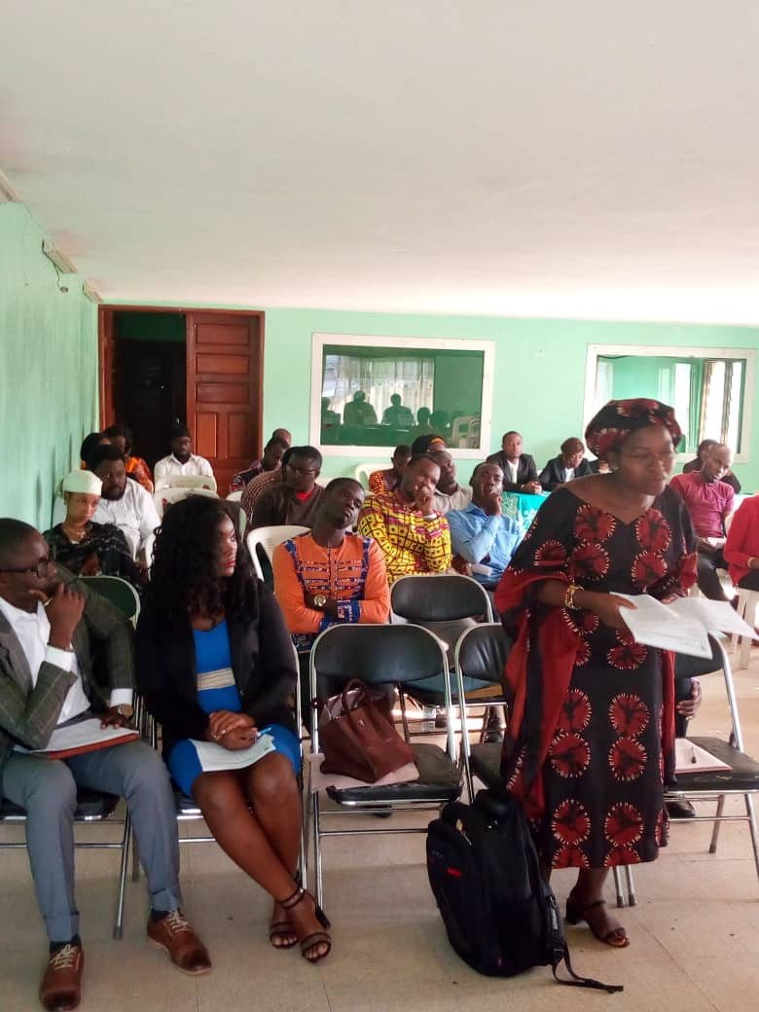

Plus de 50 personnes étaient conviées à l’atelier, mais 41 ont répondu présentes ; ce qui représente un pourcentage de participation assez considérable.
Les participants ont manifesté beaucoup d’intérêt pour la conférence d’où les multiples questions posées à l’endroit des exposants et les contributions apportées. Les réponses aux différentes préoccupations ont permis de valider l’un des objectifs initiaux, qui était celui d’augmenter chez les invités, la compréhension de l’ITIE et de sa mise en œuvre.
Les principales interventions avaient trait aux moyens de diffusion de l’ITIE, à la question des femmes orpailleuses, au transfert de compétences au sein des organismes de la société civile et au leadership. En réaction à ces questionnements, il a été révélé qu’il existait plusieurs canaux permettant de diffuser les informations relatives à l’ITIE, à l’instar des documents dont certains furent octroyés à l’assemblée par le SeP et la DMJ ; les journaux, les radios et les OSC. Par ailleurs, au sujet des difficultés rencontrées par les femmes orpailleuses à l’Est du Cameroun, certains participants étaient curieux de savoir pourquoi elles ne s’adonnaient pas à d’autres activités. Mais il a été démontré qu’en l’absence ou à cause de la rareté des champs cultivables, et en raison de l’ignorance de ces dernières au sujet des normes ITIE, elles demeuraient dans l’orfèvrerie ou se livraient aux fléaux sociaux. Ce qui impactait défavorablement sur l’équilibre du genre, dont l’aboutissement dépendrait selon les exposants, de la volonté politique et du genre masculin. Au-delà de l’affirmation de l’existence du transfert de compétence au sein des OSC, la question du leadership a été scrutée. Il a été démontré que leadership impliquait un pouvoir de décision, même dans les plus petits actes.
Par ailleurs, les expériences partagées par certains leaders des organismes de la société civile telles que RELUFA, CAFAM, Transparency International ; et des entreprises à l’instar de Jobysflash ; ou encore par des étudiants en doctorat ont relevé l’importance de la compréhension et de la mise en œuvre de l’ITIE. Le récit de leurs activités de terrain et de leurs multiples réalisations visant le combat pour la transparence, la lutte contre la corruption et le respect de l’environnement, ont énormément édifié le public et complété les principales présentations de la conférence.
Si le contenu de la conférence a eu une bonne résonnance, le facteur temps n’a néanmoins pas été respecté par les invités. En effet, l’arrivée tardive de ces derniers a créé un décalage horaire dans toutes les articulations de la conférence. Toutefois, le caractère intéressant de la conférence et les prouesses saluées du modérateur ont pallié cette insuffisance.

ANALYSE DE L’ACTIVITE

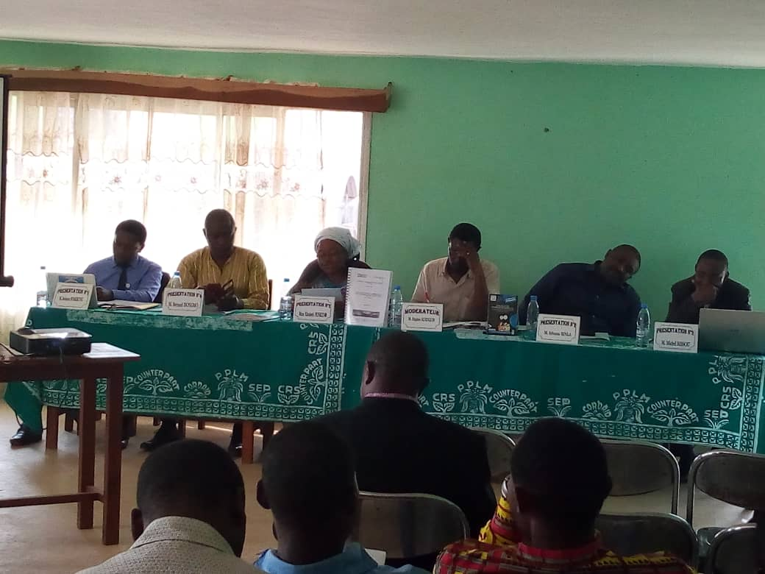

RECOMMENDATIONS

Au terme des présentations et des échanges, quelques recommandations ont été formulées pour une meilleure mise en œuvre de l’ITIE.

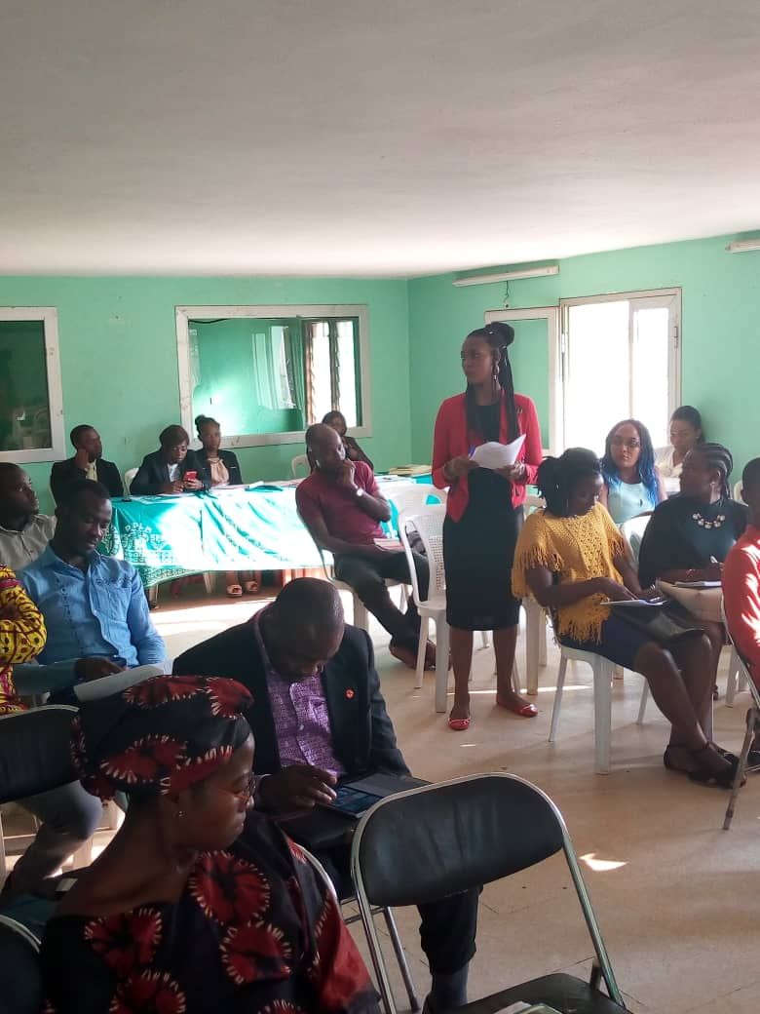

- A l’endroit du gouvernement :
-Publier les différents paiements effectués par les entreprises auprès du gouvernement ;
-Veiller à la redistribution légale des retombées de l’exploitation des ressources minières entre les riverains ;
-Prôner plus de transparence et de justice dans la gestion des ressources extractives.

- Au regard des entreprises et de la société civile :

-Les entreprises doivent déclarer ce qu’elles paient au gouvernement ;
-La société civile doit être informée et formée sur les questions du secteur de l’ITIE
-Les OSC doivent procéder à un examen systémique des revenus de la femme sur le plan de la croissance et de l’emploi ;
-Elles doivent continuer de rendre visible leurs capacités en plaidant pour les femmes et les enfants ;
-Elles doivent organiser des rencontres avec les orpailleuses pour leur permettre de s’exprimer, et octroyer un temps de parole plus long à la femme ;
-Elles doivent approcher les responsables des CTD et les femmes leaders d’opinion ;
-Elles doivent conduire les femmes dans le secteur de l’épargne et du crédit pour développer l’autonomisation financière ;
-Elles doivent structurer les femmes en points focaux CAFAM.

Conclusion

The year 2018 was a year of institutional reinforcement of the capacities of the staff of the Ecumencial Service for Peace (SeP) in other to be more efficient in the future interventions. The board of directors supported all actions at the operational level. The Ecumencial Service for Peace will be more active in the year 2019 with the organization of training workshops, conferences and citizen discussions.

